

**IBM Resiliency Orchestration Agent Based RBR for AIX consolidated Guide**

**Version 1.0**

DISCLAIMER

IBM believes that the information in this publication is accurate as of its publication date. The information is subject to change without notice.

COPYRIGHT

©IBM Corporation 2003, 2021. All Rights Reserved.

Printed December 2021.

Use, copy, and distribution of any IBM software described in this publication needs an applicable software license.

No part of this product or document may be reproduced, stored in a retrieval system, or transmitted, in any form by any means, electronic, mechanical, photocopy, recording, or otherwise, without the prior written authorization of IBM Corporation and its licensors, if any.

Revision History

We have updated documentation to reflect changes in terminologies from whitelist to allow list and Master/Slave to Primary/Standby. You will encounter continued references to these former terminologies while we work to implement these deeper changes to code, API, and CLI commands.

|  |  |  |  |  |
| --- | --- | --- | --- | --- |
| **Document Version** | **Revision Date** | **Sections Updated** | **Pages Updated** | **Supported Product Version** |
| 1.0 | December 2021 | All sections | NA | 8.2.6 |

Contents

1. Introduction 7

Purpose 7

Scope 7

Overview 7

Audience 7

References 7

2. Solution Design 8

2.1 Architecture Diagram 8

2.2 IBM Resiliency Orchestration (IBM RO) 8

2.3 IBM Resiliency Orchestration Site Controller (IBM SC) 9

2.4 IBM Resiliency Orchestration Agents (Local and Remote) 9

2.5 IBM Data Mobility Console (IBM DMC) 9

2.6 IBM Agent based RBR 9

2.7 Solution Overview 9

2.8 Different types of solution signature 10

3. Supported Platforms and Versions 12

3.1 OS Platform and Version 12

4. Agent based RBR 13

4.1 Introduction of Agent based RBR Components 13

5. Installation 20

5.1 Installation of IBM RO, IBM RO SC, IBM RO Local Agent, and IBM DMC 20

5.2 Installation of IBM Agent based RBR 20

6. HACMP Cluster protection 21

7. Pre-requisites & Known Limitations 23

7.1 Common Prerequisites: 23

7.2 Solution specific Prerequisites 26

7.3 Limitations for events: 26

7.4 OnPrem to Cloud 26

7.5 OnPrem to OnPrem 26

7.6 OnPrem to Cloud: 26

7.7 Known Limitation: 26

7.8 BAB, Journal Sizing and Staging Server Sizing 27

7.9 Features currently requiring manual execution 28

8. Auto Discovery 29

Group Creation using Discovery Simplification Service (DSS) Tool (AIX LPAR configured with Power HMC) 29

Management Service 34

Viewing AIX Credentials 40

Editing AIX Credentials 40

Sites And Subsystem Discovery 40

9. Recovery Group 41

OnPrem to Cloud 41

Cloud to Cloud 41

OnPrem to OnPrem 41

10. Application Group 43

Group creation for OnPrem to Cloud 44

11. Monitoring 45

RPO/RTO Monitoring 45

App RPO 45

Data RPO 45

Recovery Time Objective 45

Replication Monitoring 46

Replication Status 46

Datalag 46

Stop Replication 46

Start Replication 46

Replication Detail 46

Events 47

12. Drills & BCOs 48

Normal Full Copy (NFC) 48

Protect AIX LPAR Cluster nodes 49

Normal Copy 51

Drills 51

BCO 62

Recovery Automation Library 91

13. Solution Appendix 114

14. Solution Pre-requisites tools 119

15. Questionnaire tools 119

16. Troubleshooting section 119

17. Abbreviations 119

## Introduction

### Purpose

This consolidated document describes the technical details for developing disaster recovery solutions for AIX LPAR’s on IBM Power Systems with Power Hardware Management Console (HMC) on-prem/Cloud to on-prem/Clou using guest OS-based IBM RBR as continuous replication mechanism.

### Scope

This document covers replication monitoring, (Failover, FOTE) exercises using IBM RBR as replication mechanism.

### Overview

There can be many solutions that can be built using this document. This document explains the commands and the features of the replication in detail. It also contains the steps to perform drills, Failover, or Failover Tests.

### Audience

This document is intended primarily for the IBM RO product development team, also known as engineering. The secondary audience would be Professional Services and Technical Publications groups. This is a consolidated document for “AIX LPAR Protection on IBM Power systems on-prem/Cloud to on-prem/Cloud using RBR” solution developers to implement solutions with this replicator.

### References

* IBM BLOCK REPLICATOR* Admin Guide
* IBM BLOCK REPLICATOR* Message Guide.
* IBM BLOCK REPLICATOR* installer documents.
* IBM Power Hardware Management Console (HMC) / Power HMC REST API documentation (<ftp://public.dhe.ibm.com/systems/power/docs/hw/p9/p9ehl.pdf>)
* Discovery Simplification Setup guide (<https://confluence-dal10-01.sl.bluecloud.ibm.com/display/RO/Discovery+Simplification+setup+document>)
* Discovery Simplification User Manual (<https://confluence-dal10-01.sl.bluecloud.ibm.com/pages/viewpage.action?spaceKey=RO&title=Discovery+Simplification+User+Manual>)

## Solution Design

The solution describes “IBM Power Systems with HMC – AIX LPAR Protection with RBR”.

### Architecture Diagram

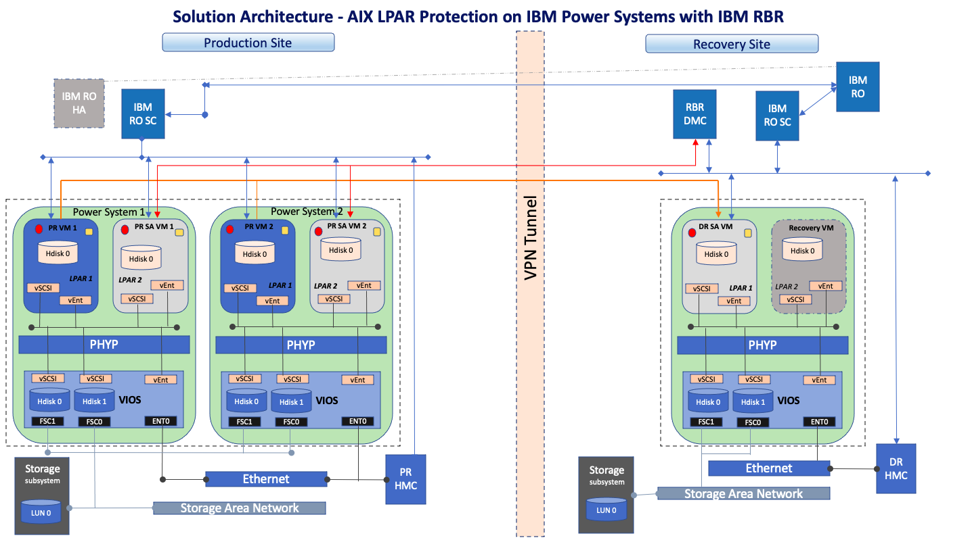

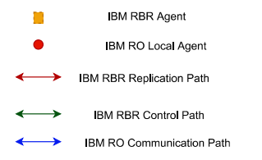

### IBM Resiliency Orchestration (IBM RO)

The IBM RO is primarily deployed on the DR site representing recovery site and the IBM RO component can also be set up as high availability across two sites. IBM RO deployed on Recovery site acts as Primary and the component on Primary site acts as Standby state.

### IBM Resiliency Orchestration Site Controller (IBM SC)

The Agent Node also called as the Site Controller, hosts the necessary or applicable Agents to manage the Endpoints remotely. The Site Controller manages the Agents for IBM Resiliency Orchestration by optimizing the communication between an Agent and the IBM Resiliency Orchestration Server.

The Site Controller augments by acting as a gateway for the set of agents for communicating with the IBM Resiliency Orchestration Server.

### IBM Resiliency Orchestration Agents (Local and Remote)

The RO Local Agents play a vital role in monitoring and managing the Endpoints and the applications on the Endpoints. The IBM Resiliency Orchestration Agents are specifically designed to manage applications, components, datasets, and the protection or replication schemas that are hosted on the Production or Primary Endpoints. The same Agents are used to manage the DR Endpoints too. The Agents are collectively managed by the IBM Resiliency Orchestration Site Controller.

If the Agents are installed in the Endpoint hardware, then they are called as Local Agents (the agents are Local to the PR or DR Endpoint). If the Agents are installed in the node where the IBM Resiliency Orchestration Server is installed, then they are called as Remote Agents (the agents are remote to the PR or DR Endpoint).

### IBM Data Mobility Console (IBM DMC)

IBM RBR component named DMC is deployed on Windows 2016/2019 VM running on recovery site. It is used to create and manage Replication between Protected LPARs and Staging LPARs. IBM Block Replicator synchronizes disk block-based data from LPAR disks on a Primary AIX LPAR to DR AIX LPAR on a Secondary System (Staging LPAR), across any available TCP/IP network connection.

### IBM Agent based RBR

As in the diagram, each protected LPAR on the primary Power server’s environment has an Agent based RBR installed and the Staging LPAR is set up on the target IBM Power server environment for the production LPARs disks replication to target disks on the staging server. This solution is confined to only AIX operating system workloads and hence the stating server is an AIX server. There is a need for staging LPAR per Power Server environment.

### Solution Overview

In this solution, IBM RBR (DMC) is created as a Management service in IBM RO which is used to discover and protect IBM Power server production LPARs.

Resiliency orchestration supports Recovery operation with a set of standard workflows for FOTE, FO, and FB. Also, it supports Replication Monitoring like RPO, Datalag, and generating alerts and reports.

**Failover Test Execution (FOTE)**

In the case of FOTE, the target LPARs are created on the target Power System by taking the replication as a checkpoint. These LPARs will be in a bubble network for DR.

**Failover (FO)**

When the Production LPAR is down and replication is stopped, our FO workflow will create a target Failover LPAR on the DR site.

**Fallback (FB)**

In case FB, a PR staging appliance for RBR is used with the new production side virtual disks created and attached to the PRsideSALPAR and a full replication setup and sync done from DRside LPAR to PRsideSALPAR. After a full replication is complete the new PRsideLPAR is auto provisioned by RO and the relevant workloads are recovered on the new PRsideLPAR while stopping the DRLPAR. Fallback is not supported in IBM RO 8.2.6 release.

**Fallback Resynch**

In the Case of Fallback Resynch, replication is set up from PRLPAR to DRSALPAR with full replication from PRsideLPAR to DRsideSALPAR. Clean-up of the Failover components (DRsideLPAR, DR Pstore disk) is performed after FB resynch is successful and relevant activity completed. Fallback Resynch is not supported in IBM RO 8.2.6 release.

### Different types of solution signature

#### Architecture Overview onPrem to Cloud

The solution describes “AIX Power VS application recovery with IBM resiliency orchestration using IBM CloudNative RBR”.

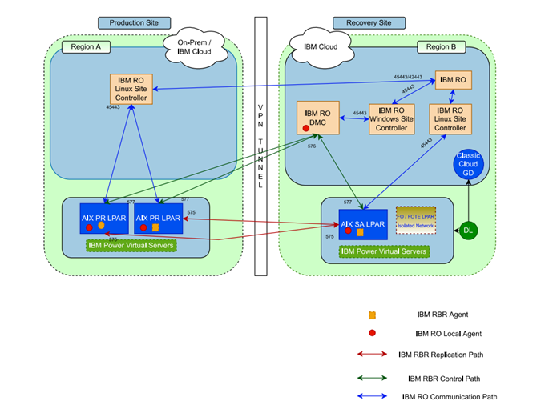

#### Architecture Overview Cloud to Cloud

Refer diagram 2.8.1 Architecture diagram

#### Architecture Overview Cloud to OnPrem

Can be validated based on customer request.

#### Architecture Overview onPrem to onPrem

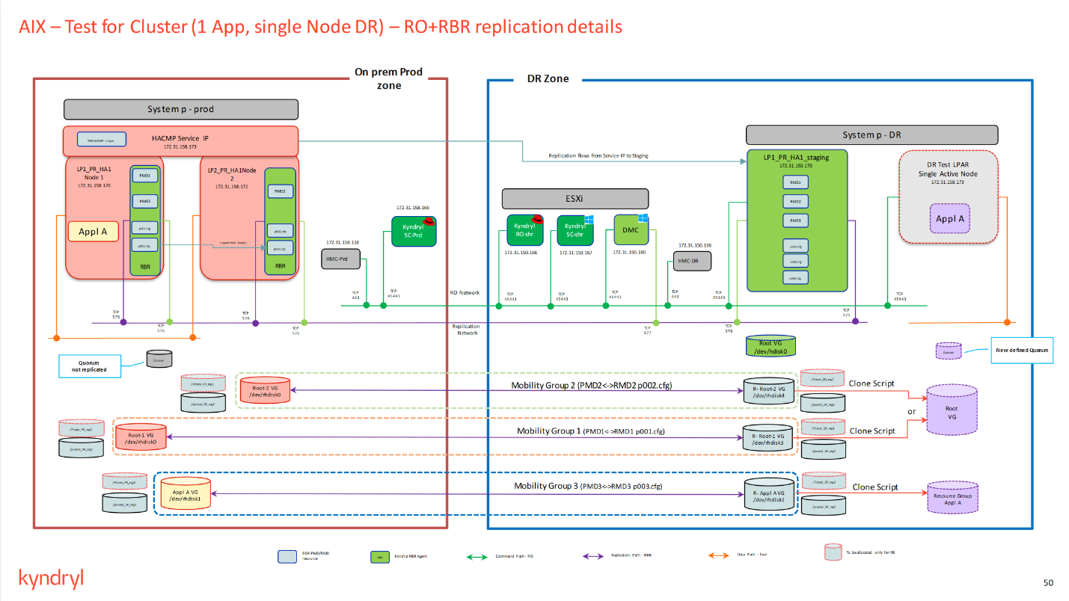

## Supported Platforms and Versions



### OS Platform and Version

* OnPrem to OnPrem Solution IBM HMC version to be 9.x
* For more information, refer to the Interop Guide

|  |  |  |  |
| --- | --- | --- | --- |
| **SL NO.** | **CATEGORY** | **OS VERSION** | **SW VERSION** |
| 1 | IBM RO | RHEL 8.0/8.1/8.2/8.3/8.4 | 8.2.6 |
| 2 | IBM RO SC | RHEL 8.0/8.1/8.2/8.3/8.4 | 8.2.6 |
| 3 | IBM RO Local Agents | RHEL 8.0/8.1/8.2/8.3/8.4 | 8.2.6 |
| 4 | DMC | Windows Server 2016, 2019 | 3.2.6 |
| 5 | IBM Agent based RBR | AIX 6.1, 7.1, 7.2 (with JFS & JFS2) | 3.2.6 |

## Agent based RBR



### Introduction of Agent based RBR Components

The basic replication environment consists of *Mobility Servers*. *Mobility Servers* are the servers from which, and to which, data is transferred. In a basic replication environment, there are two types of *Mobility Server*s: Primary Servers and Secondary Servers.

**Primary Servers:** The original servers containing the source volumes, from which data is mirrored.

**Secondary Servers:** The backup servers containing the target volumes, to which data is mirrored. Primary Servers and Secondary Servers need not be exclusionary. One server can serve as both a Primary Server on one volume, and a Secondary Server on another volume.

UNIX *Mobility Server*s can also receive commands from the IBM Data Mobility Console

through the DMC Collector. They also send statistical records, performance data, and event logs

to the DMC Collector and keep the DMC Collector informed of any changes or problems. For

more information on IBM Data Mobility Console and the DMC Collector

This document covers Agent based RBR solutions.



The driver is named IBM Resiliency Block Replicator Agent.

#### Primary Server

The *Primary Server* provides application access and data storage services to users. The Primary server must be running on AIX operating system, have active TCP/IP connections to the Secondary Server and have enough disk space and memory available to run IBM Agent based RBR.

After installing IBM Agent based RBR on the Primary Server, you will have the following

components:

* Mobility Groups
* Configuration Files
* IBM Agent based RBR Master Daemon: in.dtc
* IBM Agent based RBR Agent Daemon: in.dua
* Primary Mirror Daemon (PMD)
* Big Asynchronous Buffer (BAB)
* Pstore

**Mobility Groups**

A *Mobility Group* is a collection of *source partitions* or *source volumes* treated as a single unit by Softek Agent based RBR (IP). Each Mobility Group operates with its own independent PMD/RMD daemon pair. Mobility Groups allow time-ordered writing coherence between member replication pairs, and complete operational and state independence.



**Source Volume**

The Source Volume is a hdisk associated with the Primary Server. A Source Volume is specified as a special character device and acts as the interface to the block mode device. Data stored on a Source Volume is duplicated onto the Secondary Server, so the Source Volume must have a correlating target volume of equal or greater size on the Secondary Server. You specify the Source Volume to be included in the IBM Agent based RBR profile during the configuration.

**Configuration Files**

For each Mobility Group on the Primary Server, IBM Agent based RBR creates a configuration file. These configuration files contain Mobility Group definitions for the source and target volumes. The naming convention for the configuration files corresponds to the Mobility Group’s number and prefixed with the letter “p” on the Primary Server. For example, p000.cfg corresponds to Mobility Group 0 on the Primary Server. Creation of configuration files (MGs) will be made from DMC. The steps will be mentioned in the upcoming sections.

**Agent based RBR (IP) Master Daemon: in.dtc**

When installing IBM Agent based RBR, a user-mode background program is installed. The in.dtc establishes and manages both the PMD (Primary Mirror Daemon) and RMD (Remote Mirror Daemon) processes for each defined Mobility Group. This daemon also launches the process that manages and evaluates throttles for each Mobility Group of devices.

**Agent based RBR (IP) Agent Daemon: in.dua**

After IBM Agent based RBR Installation, we need to provide the DMC IP, DMC Port, Server IP, Server Listening Port and BAB requirement with dtcagentset command. Then we need to launch the agent. Required in.dua process (4 processes) will be created and establish communication with DMC. This process will update the monitoring details like replication status, RPO, RTO, data lag, etc to DMC. DMC will also send the commands to the Agent to perform the operations like start the replication, checkpoint, creation of MG, etc.

**Primary Mirror Daemon (PMD)**

The Primary Mirror Daemon (PMD) is a background process running on the Primary Server. Each Mobility Group has one PMD that is started automatically by the master daemon as part of the system boot script or using the launchpmds or launchrefresh command. The PMD removes entries out of the BAB and sends them to the corresponding RMD on the Secondary Server. There is an independent PMD process for each Mobility Group defined on the Primary Server, so each Mobility Group can connect to a unique Secondary Server.

**Big Asynchronous Buffer (BAB)**

IBM Agent based RBR uses a large kernel buffer called the Big Asynchronous Buffer (BAB) to journal updates as they are written to the source volume. This buffer resides in the physical kernel memory owned by the operating system. You must allocate this kernel memory to IBM Agent based RBR during the initial configuration. Writes to a replicated device are simultaneously logged in the BAB and written to the source volume. Chronological coherence is maintained on a Mobility Group basis, therefore each Mobility Group assumes a portion of the BAB and updates to the devices in that Mobility Group are journaled sequentially within the area allocated. The entire memory designated for the BAB is allocated dynamically (on an as-needed basis) among Mobility Groups. During configuration, you specify the memory allocated for the BAB.

**Pstore**

A Persistent Store (Pstore) is a volume on the Primary Server that stores state information, tuneable parameter definitions, and tracking data about the Mobility Groups, as well bitmaps which track updates to the source volumes. When a block is updated on the source volume, the the bit is turned on; when that block has been successfully transferred to the target volume, the bit is turned off.

During configuration, you can define a single Pstore LV for all normal Mobility Groups and each Pstore LV for each RG in HACMP Cluster. Each Pstore LV should be in an individual separate hdisk. For RG cluster config, each Pstore hdisk should be part of the respective RG.

The Pstore consists of two components: a memory-resident component, **HRT**, and a disk-based component, **LRT**. Both the HRT and LRT have two sections: a header section that keeps track of current Mobility Group and device states and a bitmap section.

* HRT – High-Resolution Tracking. This is a memory-based bitmap. It is 128 kilobits for each device and is used in *refresh* processing.
* LRT – Low-Resolution Tracking. This is a disk-based bitmap. It is eight Kbytes’ for each device, used only in recovery mode when the Primary Server has failed.

The bitmaps are of fixed size and the granularity varies depending on the size of the volume the larger the volume the more data each bit represents.

There are only two situations where the bitmaps will not be valid:

* If a Mobility Group has been in *Passthru* state, no tracking is done on updates to the source volume.
* If the Mobility Group is STOPPED, then tracking in the bitmaps is stopped as well.

In both cases, the only way to get back to a consistent state is to run either a *Full* or *Checksum*

*Refresh*. Also, I/O is not tracked on the target volumes, so if the target volumes are updated in *Checkpoint* or *Tracking* state, a *Full* or *Checksum Refresh* must be run to get back into a consistent state.

If you are replicating large volumes and will be using large bitmaps, ensure that you allocate 12 MB per device for the Pstore. If you intend to use the smaller-sized bitmaps, allow 140 KB per device for the Pstore.

If you use proportional HRT bitmaps (proportional to devise size), there is no exact multiplication factor to apply to the number of devices, as the bitmap size will hange from one device to another. A script called dtchrdb_maths is available as part of the package tohelp determine the HRT (also referred to as HRDB) size for given device size, at each possible resolution level (low, medium, and high).

* The HRT types are mutually exclusive and global to a single server. You cannot have a mix of Small, Large, and Proportional HRT types on the same server. However, if you select the Proportional HRT type, the tracking granularity (bit resolution or mapping) can vary from one Pstore to another (among the choices of low, medium, and high resolution).
* The main concept behind Proportional HRT is that you do not select the HRDB size at Pstore initialization time but the HRDB tracking resolution level (low, medium, or high) on the basis of which the HRDB size will be calculated depending on the size of the device. The related resolution values are defined in a configuration file called **dtcTracking_Resolution.txt** and are installed in the same directory as the group configuration files. You also define in this file the maximum HRDB size allowed for each resolution level.

# All numbers are in KB (resolutions are KBs per bit)

# WARNING: resolution values must be power of 2

LOW_RESOLUTION=64;

MAX_HRDB_SIZE_LOW=4096;

MEDIUM_RESOLUTION=32;

MAX_HRDB_SIZE_MEDIUM=8192;

HIGH_RESOLUTION=8;

MAX_HRDB_SIZE_HIGH=16384;

#### Secondary Server

The *Secondary server* is the server on which IBM Agent based RBR replicates data from the Primary Server. During normal operation, this server provides a *mirror* of the data. The functionality of each system is defined in the configuration files, which you define on the Primary Server and copy to the Secondary. This allows you to switch the roles of Mobility Servers in IBM Agent based RBR more easily. All applications used on the Primary Server should also be on the Secondary Server to allow you to switch operations over to the Secondary Server if needed. Target volumes and journal file directories are set up on the Secondary Server. The master daemon process (*in.dtc*) running on the Secondary Server launches an RMD for each Mobility Group.

After installing IBM Agent based RBR on the Secondary Server, you can configure the following

components:

* Remote Mirror Daemon (RMD)
* Target Volume
* Journal File Directory

**Remote Mirror Daemon (RMD)**

The Remote Mirror Daemon (RMD) is a background process running on the Secondary Server. Each Mobility Group has one RMD that is started automatically by the master daemon as part of the system boot script or using the launchrefresh command.

The RMD receives entries from the corresponding PMD on the Primary Server and writes the data to the target volumes. If you stop a PMD on the Primary Server, its corresponding RMD is automatically brought down.

**Target Volume**

A *target volume* is specified as a special character device (but pertains to both the special character and corresponding block mode devices) on the Secondary Server. You must have a target volume on the Secondary Server for each source volume on the Primary Server. The target volume must be the **same size or larger than** the corresponding source volume.

During normal operation, the target volume contains a coherent—that is, usable—a copy of the data stored on the Primary Server. You can checkpoint the data on these devices, and applications other than IBM Agent based RBR can open target volumes in read-only mode.

**Journal File Directory**

The *journal file directory* is used during a *Smart Refresh* operation, to store updates which, if applied to the target volume, would place it in an incoherent state. The journal file directory is also used to store updates while the checkpoint is active on the target volumes. These changes are eventually applied to the target volume to maintain coherence. These entries are saved to the target volume only after the PMD indicates that all updates have been transferred. You can set the journal file directories to any writable directory during configuration.

A new journal file is created each time there is a state change that causes the data being transferred to go from coherent to incoherent. IBM Agent based RBR uses the following naming convention for these files:

j###.########.c (for coherent state)

j###.########.i (for incoherent state)

The “j” indicates that this is a journal file, the first three numbers represent the Mobility Group to which the journal file belongs, and the second set of numbers are sequence numbers of journal files for each Mobility Group.

For example:

j001.00000002.c (the second journal file for Mobility Group 1 in a coherent state)

## Installation



### Installation of IBM RO, IBM RO SC, IBM RO Local Agent, and IBM DMC

Please refer to “IBM Resiliency Orchestration Installation Guide 8.2.6”.

### Installation of IBM Agent based RBR

* Login to both the AIX LPARs as root user.
* Create /var/dtc folder.
  + mkdir /var/dtc
* Extract the Agent based RBR package to dtc.rte file
  + uncompress TDMFIP-AIX61-03.02.0002.0000-DEV20210824060438.rs6000.tar.Z
  + tar -xvf TDMFIP-AIX61-03.02.0002.0000-DEV20210824060438.rs6000.tar
* Install the binary dtc.rte file.
  + installp -a -V 4 -e /var/dtc/dtc_install.log -d . dtc.rte
* Verify the installation
  + lslpp -l | grep dtc
* Set the DMC configurations
  + /usr/dtc/bin/dtcagentset -e <DMC IP>/576 -i <LPAR IP> -p 577 -b 256
* Launch the Agent
  + /usr/dtc/bin/launchagent
* Verify the Agent
  + Ps -eaf | grep in.dua

## HACMP Cluster protection

In case HACMP Cluster nodes protection along with running resource groups, these are additional recommendations and related reference architecture.

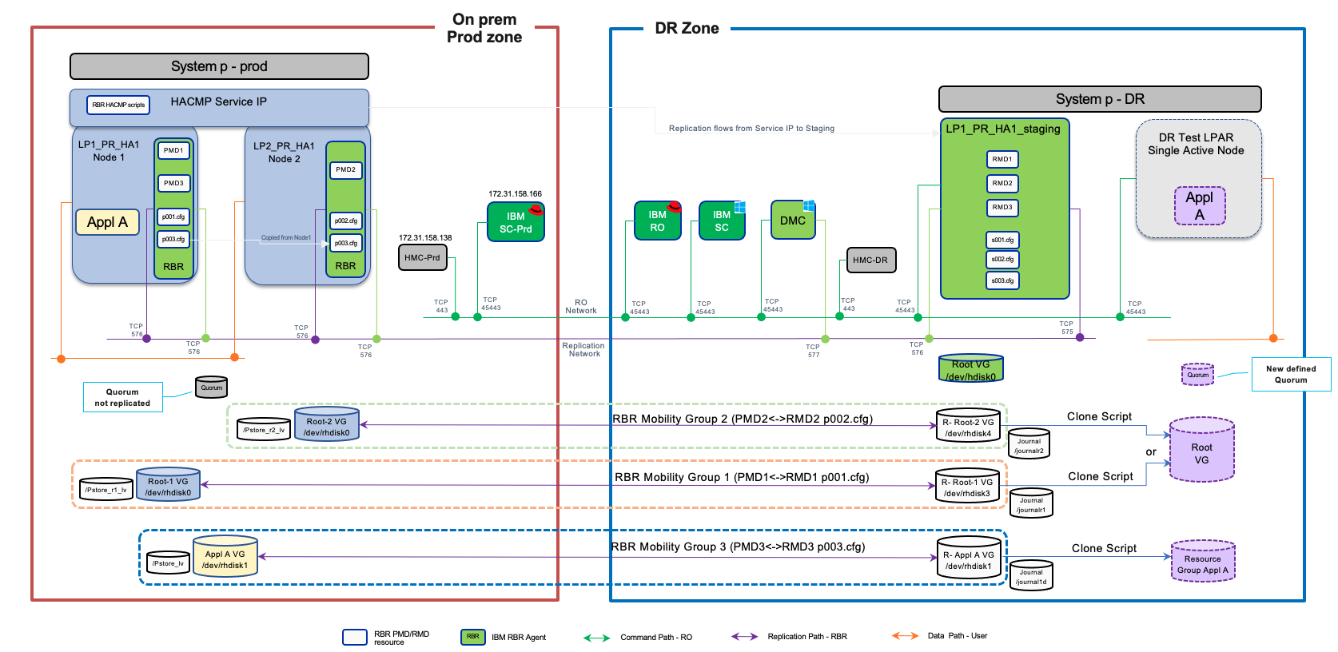

AIX LPAR cluster nodes are discovered as IBM RO components. IBM RO communicates with Cluster node LPARs via RO local agent or remote agent for cluster service and resource group details or discovery.

In HACMP cluster protection, there are two levels of protection with individual RBR mobility groups. Each LPAR cluster node OS disk and related other local VG disks are protected with one Mobility Group. Individual running cluster resource groups related disks are protected with separate and individual mobility groups and configured using resource group service IP address as primary replication link.

The RBR replication traffic i.e., TCP port 575 should also be allowed between resource group Service IP and DR Staging LPAR. The data replication for individual resource groups occurs between resource group service ip and DR Staging LPAR.

RBR network connection should also be opened between the DMC component and resource group service IP.

The solution supports Recovery operation (Failover) and DR Test (Failover test exercise) for the HACMP Cluster with a set of standard workflows.

In the case of Failover (FO), the target LPARs (LPARs) are created on the target Power server in a bubble network (as defined by DR Admin as pre-requisites) for DR, where production LPAR will be down as well as replication will be stopped. The cluster resource groups related disks are also attached to recovery LPAR and brought up Cluster & related resource groups online.

In the case Failover Test Exercise (FOTE), the snapshot disk clones are created from replicated disk using underlined storage For example, Netapp. This operation is executed on the Cluster node and resource group replicated disks. The target TEST LPARs are created and attached with all snapshot clone disks. The cluster service and related resource groups are brought up online.

## Pre-requisites & Known Limitations



### Common Prerequisites:

* IBM Power HMC API call to discover, protect and recover LPARs (LPARs) on specific Power Server environment.
* RBR (Resiliency Block replicator) agent should be installed on all the required AIX LPAR’s i.e. both the Production and DR sites.
* AIX LPAR Production instance should have one disk (size – 1GB ) added on production LPAR, required for Pstore (RBR) purpose.
* To support HACMP Cluster Resource Group protection, the participants' cluster nodes should have shared 1G disk allocated per cluster resource group, required for Pstore (RBR) purpose. Additional Volume group (VG) needs to be created using Pstore disk per resource group. The logical volume named as PStore as pre-fix to be created in the same VG and imported VG on cluster nodes. The respective Pstore VG needs to be added to the resource group.
* A staging LPAR on the target side on IBM Power Systems with the same OS Family (AIX) is required with all the target replica disks presented/mapped respectively. A staging VLPAR is also required on the PR site as part of FB operations.
* In case OS-level firewall is enabled, AIX LPAR needs to have TCP ports 575, 577, RO related ports (45443 default) opened.
* For FO, FOTE to be supported, SALPARs on DR (DRSALPAR) are required to be pre-provisioned (manual activity) with the specific configuration suggestion defined for SALPAR.
* To support Fallback for LPAR, SALPARs on the Primary site is required to be provisioned.
* Note: The number of SALPARs is dependent on the number of supported disks per LPAR.
* Microsoft Windows LPAR (Windows 2016/2019) should be deployed on the DR site and have IBM RBR DMC software installed. Also, it should have IBM RO local agent installed.
* Needs .NET Framework 3.5 to be installed on windows for DMC package installation.
* In Case an OS-level firewall is enabled; it needs to have TCP ports 576 open for In-Bound traffic.
* In the case production AIX LPAR, Block Replicator needs at least 256 MB as physical memory for BAB purposes from the allocated LPAR Memory space.
* IBM RBR Staging LPAR/AIX LPAR needs 25% disk allocation of the total protected disk storage capacity (in addition to actual target/replica disks) for the Journal. It’s recommended to use SSD type/higher tier managed disk for Journal disk space allocation on Staging LPAR and mounted on Staging LPAR OS Disk.
* Journal disk (Staging LPAR/AIX LPAR) should be formatted with native OS filesystem type and mounted as /journal.
* The number of Staging LPAR size depends on the number of Protected LPAR disks and Staging LPAR Sizing.
* The Block replicator DMC should be discovered in IBM RO as a management service.
* Production AIX LPAR should be discovered in CRO via CRO remote agent or local agent. In case CRO local agent, AIX LPAR OS should have CRO local agent installed.
* IBM RO block replicator agent is required on the DMC windows box in addition to DMC installation.

Prerequisite Port requirements

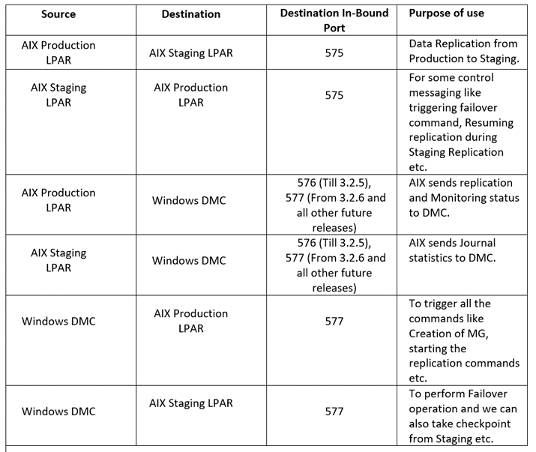

Security Requirements:

|  |  |  |  |
| --- | --- | --- | --- |
| **Category** | **Requirements** | **Detail** | **Comments** |
| Production LPAR to target Staging Block Replicator LPAR  In the case of HACMP Cluster, production resource group service IP to target Staging LPAR | Port | Default - 575(Inbound) | IBR Agent communication |
| IBM Power Systems HMC (in case of OnPrem solutions only) |  | Role with enough permission to manage and deploy LPAR, manage storage and network. | Required for IBM RO to communicate with IBM Power Systems for the managed resources discovery and protection for DR |
| DMC to Block Replicator Agent (Prod LPAR and SA LPAR) | Port | Default 577 (Inbound) | dtcagentset command is used to update the port at Block Replicator Agents |
| Block Replicator Agent to DMC | Port | Default 577 (SSL) and 576 (Non-SSL). Users can provide an SSL port as input during the installation of DMC. DMC will consider (SSL port 1) as a Non-SSL port. Note: AIX Agent supports only non-SSL ports.  All Ports are required to be inbound open | dtcagentset command is used to update this port at Block Replicator Agents |
| DMC to SC | Port | 45443(Inbound) |  |
| IBM RO and Site controller to AIX LPAR/LPAR | Port | 22 (Remote Agent), (Inbound)  45443 (Local Agent) (Inbound) | REST API |
| IBM Power HMC API from IBM RO/ Site Controller | Port | Default 443(Inbound) | API Call (for supported API applicable) |
| IBM RO to SC | Port | 45443/42443(Inbound) |  |

### Solution specific Prerequisites

### Limitations for events:

1. Post upgrade we cannot download the events for existing groups. Need to re-create the Groups.
2. When we restart the agent, events are getting vanished, we need to recreate the group.

### OnPrem to Cloud

* Ensure contributor Privilege is given to the Resource Group "RO development" in the IBM cloud RBAC



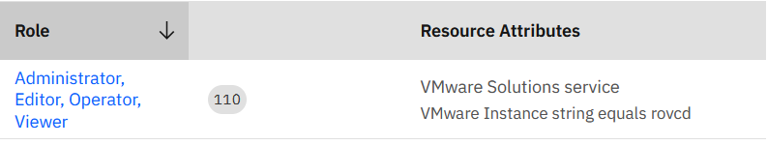

### OnPrem to OnPrem

No specific Prerequisites

### OnPrem to Cloud:

No Specific Prerequisites

### Known Limitation:

* Pstore disk creation on Production LPAR is manual as part of pre-requisite setup before discovery in RO (for initial setup).
* Journal disk creation on the Target LPAR is manual.
* To support HACMP cluster nodes and Resource Group protection with RBR, the disk device name should be the same across all participant cluster nodes.

**Sizing:**

* The maximum number of LPAR protection is 200 per DMC configured as 1 Mobility Group.

### BAB, Journal Sizing and Staging Server Sizing

**BAB Sizing:**

BAB is allocated on Primary Server to absorb temporary I/O peak rates. Its size is mainly depending on data change rate, speed of the network and time required to tolerate the network outage.

From the existing test analysis, we are advising to allocate the size of the BAB

* Small systems should have a BAB between 128 MB-256 MB
* Medium sized systems should have a BAB between 256 MB and 512 MB
* Large sized systems should have a BAB larger than 512 MB (preferably over 1 GB.)

**Note:** RBR Agent will fail if the BAB size is set to zero on the Primary Server or the system will fail if you exceed the physical memory limit

**Journal Sizing:**

Journaling on the Staging Server allows incoherent data to be transferred over the network without affecting the coherence or recoverability of the data on the mirror devices. Journaling also allows you to checkpoint (temporarily stop) mirror devices on the Staging Server, while safely accumulating new updates from the Primary Server until after the Checkpoint has been released. At that time, the journaled updates are applied to the appropriate mirror devices. This process ensures that the data on the mirror devices is known during the Checkpoint operation and allows other applications access to the mirror devices without interrupting operations on the Primary Server or requiring a Refresh.

The Staging journals are not used during a Full Refresh, but only when data is written directly to the mirror device(s)—during a Smart Refresh, when blocks of changed data are written. The journal file directory should be large enough to handle all changed data from a Smart Refresh of one or more Mobility Groups, and to accommodate the updates that occur during the Checkpoint. Knowing the rate of changes made to data on the Primary Server is also useful in estimating the amount of data written to journal files during a Checkpoint. For example, the Checkpoint allows read-only access to the mirror devices so that you can do a backup. You can determine the time to complete a backup by simply dividing the total amount of data to be backed up by the transfer speed of the selected backup device. Then, you can determine the average amount of data changed during that time period and make accommodations for data bursts. The journal file directory should be large enough to accommodate this amount of data.

The size of the journal file directory should be 25% of the entire amount of data stored on all local data devices in a Mobility Group. (A Mobility Group is a coherent set of devices that ensures time-ordered writing coherence between member devices.)

Thus, if a Mobility Group has three local data devices totalling 12 GB, then the size of the journal file directory should be 3 GB (25% of 12 GB) for this Mobility Group. During configuration, you can define a journal file directory for all Mobility Groups or for each one.

**Staging Server Sizing and Number of Staging servers:**

The number of Staging Server required depends on Number of disks being protected and number of disks that can be attached to Staging Server. If Staging server supports say 256 disks, then max number of disks which can be protected by this Staging server would be 254 or less (One disk would be used for root VG and we may need one or more disk for JOURNAL space)

The size of the staging server depends on number of mobility groups being protected by that staging server. Typically, one Staging Server of size say 4 logical core and 8 GB RAM, can protect up to 40 mobility groups (this would correspond to 40 LPAR or 20 LPAR if each LPAR is protected as 2 Mobility Group – one for root disk and one for data disks.). Please note that these sizing are guidelines since there are other factors that can affect sizing like if there are application with huge change rate, then one Staging server may not be able to support 40 such applications.

For Ex: If number of MGs are created are in the range like 1 to 10, then we can make the staging server RAM as 2 to 4GB and dedicated CPUs as 1 to 4CPUs. If the number of MGs are more, then we need to use more RAM and CPU accordingly.

For Ex: If we need to protect 500 Production disks with 100 mobility groups, If LPAR supports only 256 disks, then we need to use at least 3 staging AIX LPARS. By above calculation, we need 2 Staging Server for accommodating 500 disks, but we need one more since we have to support 100 Mobility group since one Staging server can support 40 Mobility groups. Hence only 2 staging servers.

**Note:** Number of disks supported by LPAR can get from IBM AIX OS manual.

### Features currently requiring manual execution

* Protected LPAR/LPARs on Staging LPAR/LPAR would be recovered on the target IBM Power system server as same as Staging LPAR/LPAR. The LPAR can be recovered on a different Power System if relevant resources like disks and networks can be shared across LPARs using VIOS. This kind of shared resources between LPARs is usually part of cluster environments.
* The solution does not support auto-provisioning which means that the NFC workflow is not available and hence initial full sync needs to be performed manually and mobility group name needs to be entered during group discovery
* In the case of HACMP Cluster protection, the product currently supports Failover and Failover test exercises with standard workflow. Other DR operations alike Switchover/Switchback and Fallback are not supported.
* AG auto-discovery is not supported. Users can discover AG manually.
* NFC has to be invoked via manual commands.

**Note:** Any additional/default limitations at IBM Power Systems or IBM P-Cloud may affect the Replication and Recovery.

## Auto Discovery

### Group Creation using Discovery Simplification Service (DSS) Tool (AIX LPAR configured with Power HMC)

Group is created by discovering Components, Datasets, Protection Schemes and by associating them to a site. The DSS tool simplifies and significantly reduces the time taken to discover. This section covers the procedure to create a group using the DSS tool.

**Prerequisite**

* DSS tool is installed and is accessible. To view installation instructions and to start the discovery UI and CLI application of the DSS tool, please refer to the IBM Resiliency Orchestration DSS User guide.
* For this solution, the recommended data collection tool used by the DSS application DSS is HMC API. However, it can support additional data collection tools if required. Ensure that you have AWS API access credentials.
* The Configuration.csv file is available. This csv file is used for capturing the management service details. To know the location of the csv file, refer to the IBM Resiliency Orchestration DSS User guide.

**Format for CSV file:**

<Solution name>, <management service name>, <ip address>, <port>, <site>, <site type>

* The IP address of the IBM Resiliency Orchestration Server is known to you.
* Ensure that you have PR and DR credentials with corresponding URLS.

**Steps**

Perform the following steps.

1. Enter the following details in the Configuration.csv.

| Object | Name | IP Address | Port | Site  (The value should be the same as in the IBM Resiliency Orchestration) | Site Type  (This is a noneditable column) |
| --- | --- | --- | --- | --- | --- |
| hmc | <management service component name> | <the IP Address of management service components discovered> | <Port number of management service components discovered > | PR_Site | PR |
| hmc | <management service component name> | <the IP Address of management service components discovered> | <Port number of management service components discovered > | DR_Site | DR |
| hmc | <management service component name> | <the IP Address of management service components discovered> | <Port number of management service components discovered > | BR_Site | BR |

**Note:**

* The editable columns cannot be left empty. If they need to be empty, then please provide at least one space in each column to avoid potential errors.
* If you have not discovered a management service for a particular component (scenario for recovery to clean room), then during the group creation using the DSS tool, you will need to provide a dummy name of the management as “**PlaceHolder**” as the value.

1. In the browser, access the IP address of the machine where the docker image is loaded. The DSS tool UI loads as shown below.

**Note:**

* For details on UI elements and associated features, please refer to the IBM Resiliency Orchestration DSS User guide.
* Ensure that you have updated the Configuration.csv with the management service details before proceeding to the next steps.

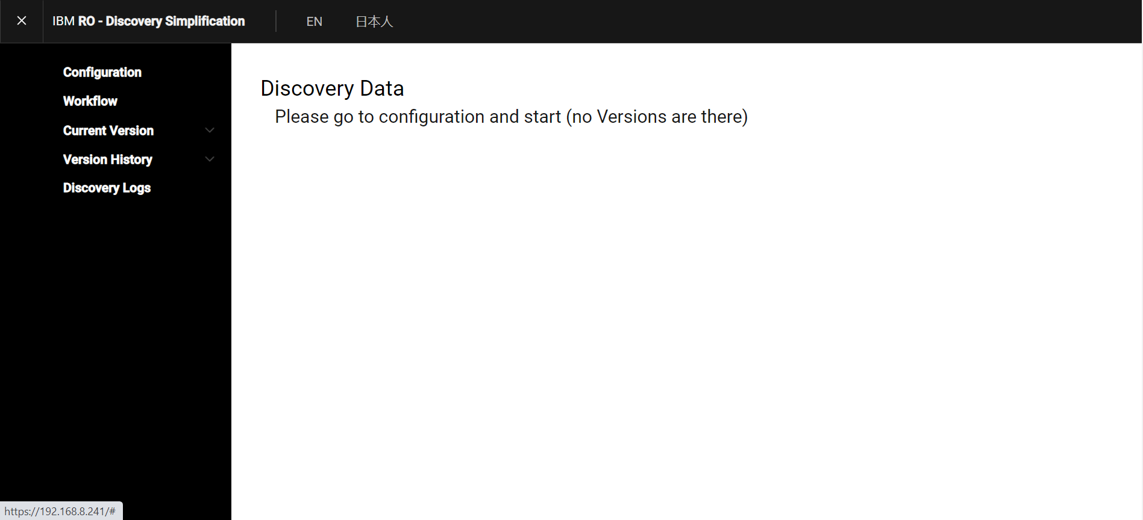

1. Select **AIX_LPAR_protection_with_RBR** from the **Select Solutions** dropdown menu.

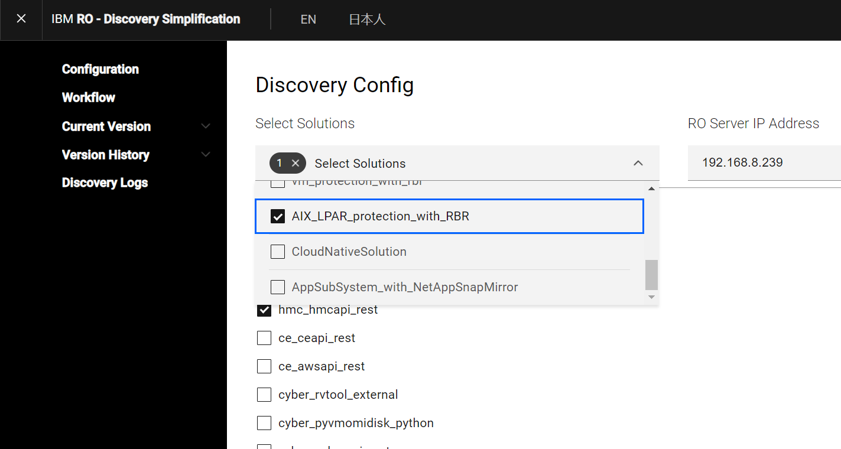

1. Enter the RO server IP to which the discovery data needs to be ingested for group creation in the **RO server IP Address** text box.

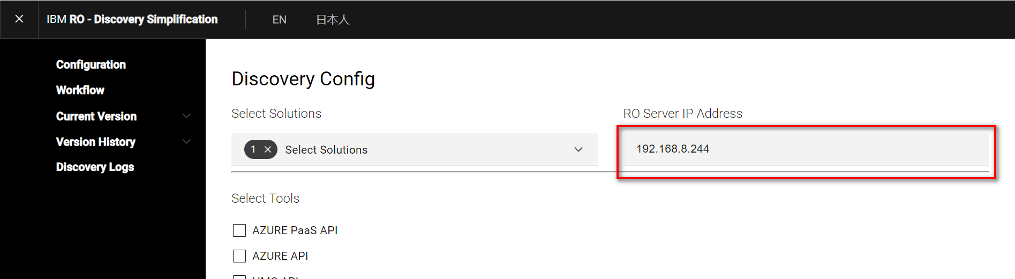

1. Ensure that the **hmc_hmcapi_rest**  checkbox is enabled from the **Select Tool** section.

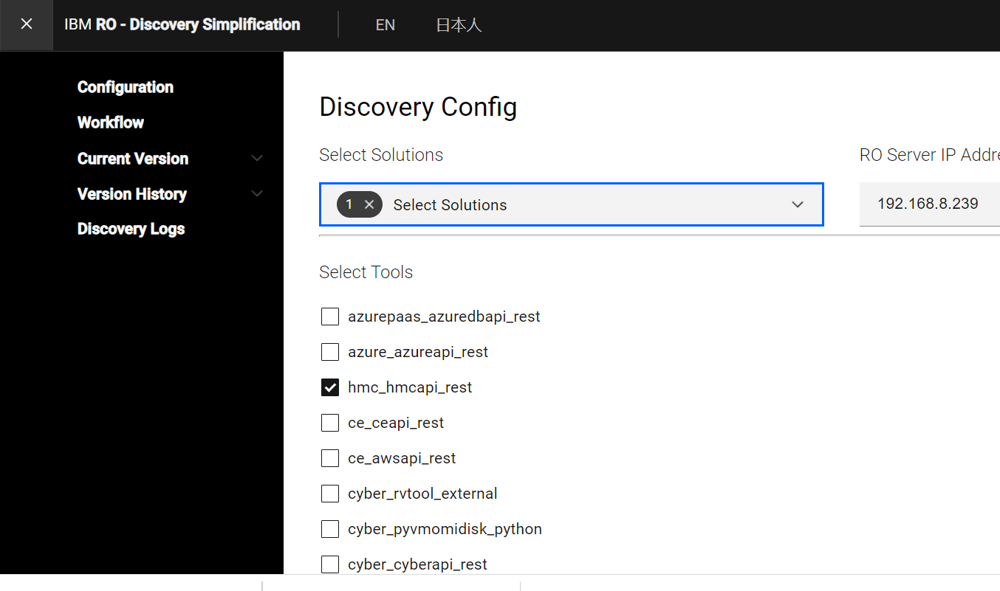

1. Click **Save & Start** to start the discovery process.
2. Enter the PR and DR access credentials and corresponding URL on the next screen and then click **Submit** button.

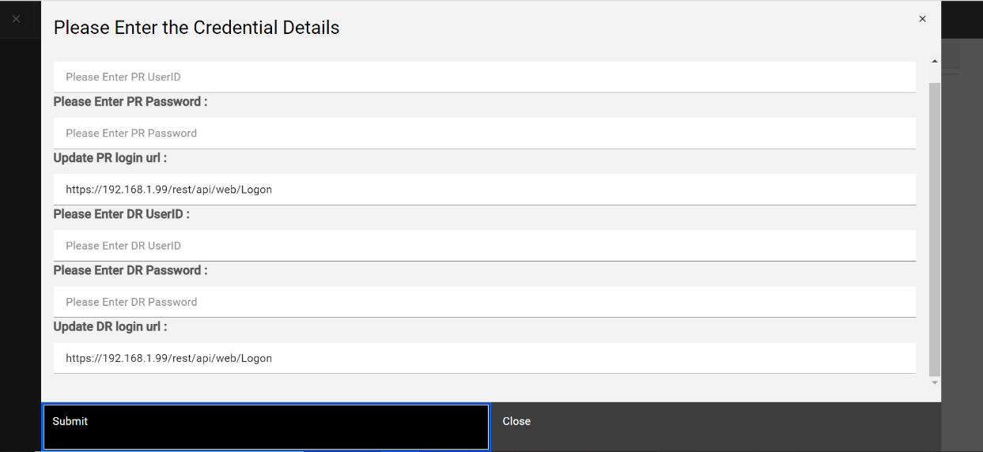

1. After the discovery is completed, click the **Close** button**.** The discovery data appears.
2. Validate the discovery information and continue to the payload generation step.
3. Click on **Generate payload** button and then click **Ok** on the confirmation dialog box that appears. This step generates the the payload.
4. Validate the data in **RO_Object** section and update any information that needs to be updated manually.
5. The RO_Object information is same as the JSON info as part of sample JSON provided in the solution.
6. Resolve any warning that are raised as part of validation of this data by DSS tool.

**Note:** Use the “+” sign to expand the table for more detailed information. For example the example above, you can expand Protected_VM and RO_Object tables.

1. Click on the **Approve** button after the validation and required details are updated and ready for group creation.
2. Enter the credentials for IBM Resiliency Orchestration server on the screen that appears. The ingestion starts and creates groups in the IBM Resiliency Orchestration credentials server in the backend.

**Note:** Ensure that the 8443 port is open on the RO server for data ingestion (based on firewall setup).

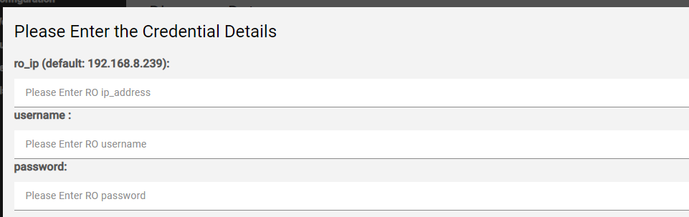

1. After ingestion is complete, click **OK** to complete the DSS Tool Discovery and group creation operation.

**Note:** You can check if the groups have been created successfully on the IBM Resiliency Orchestrator by going to **Discover -> Groups** page.

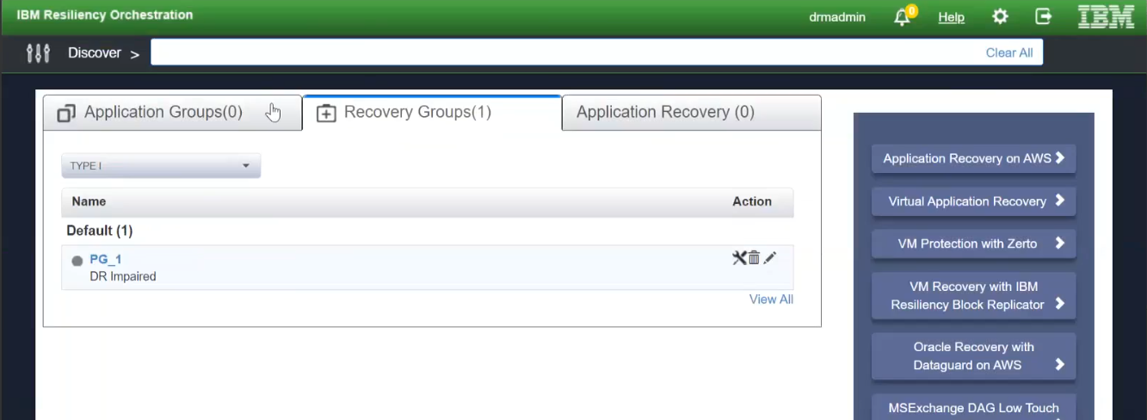

### Management Service

#### OnPrem to OnPrem

Discover the following services for remote sites:

**IBM BlockReplicator-V2 Management Service (To be discovered for Remote site)**

Go to Discovery 🡪 Management Service🡪Add Management Service 🡪 Management Service Type.

1. Select the **Management Service** type as “**BlockReplicator-V2**” and provide the **Management service Name** and **DMC Server IP**.

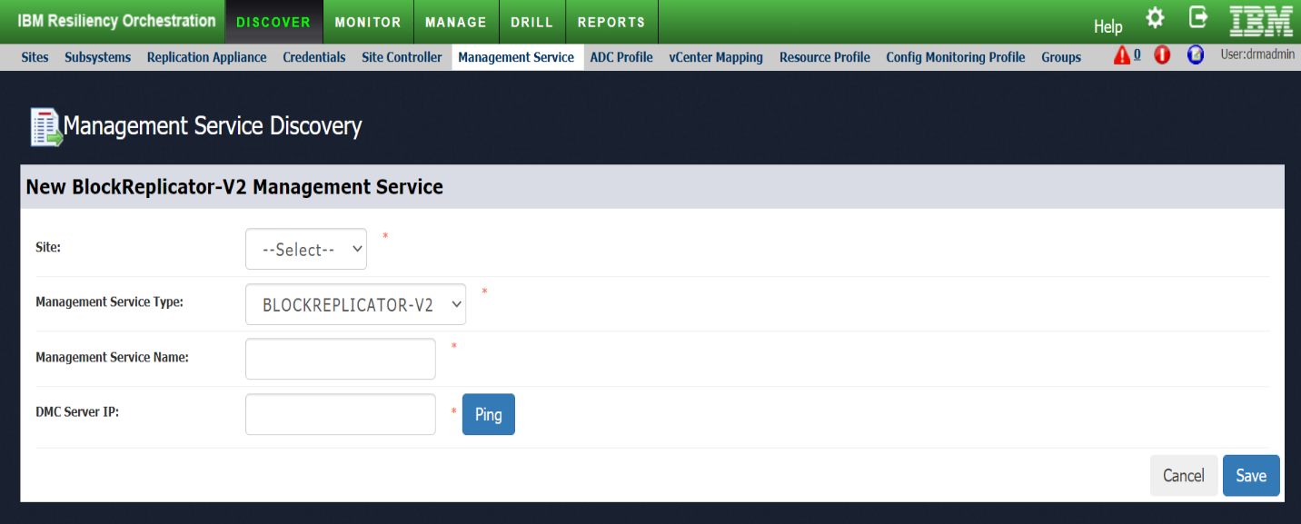

**IBM PowerHMC Management Service (To be discovered for Remote site)**

Go to **Discovery** 🡪 **Management Service**🡪**Add Management Service** 🡪 **Management Service Type**.

1. Select the **Management Service** type as “ **BlockReplicator-V2**” and provide the **Management service Name**, **PowerHMC Server IP**, Port, Username, and Credential.

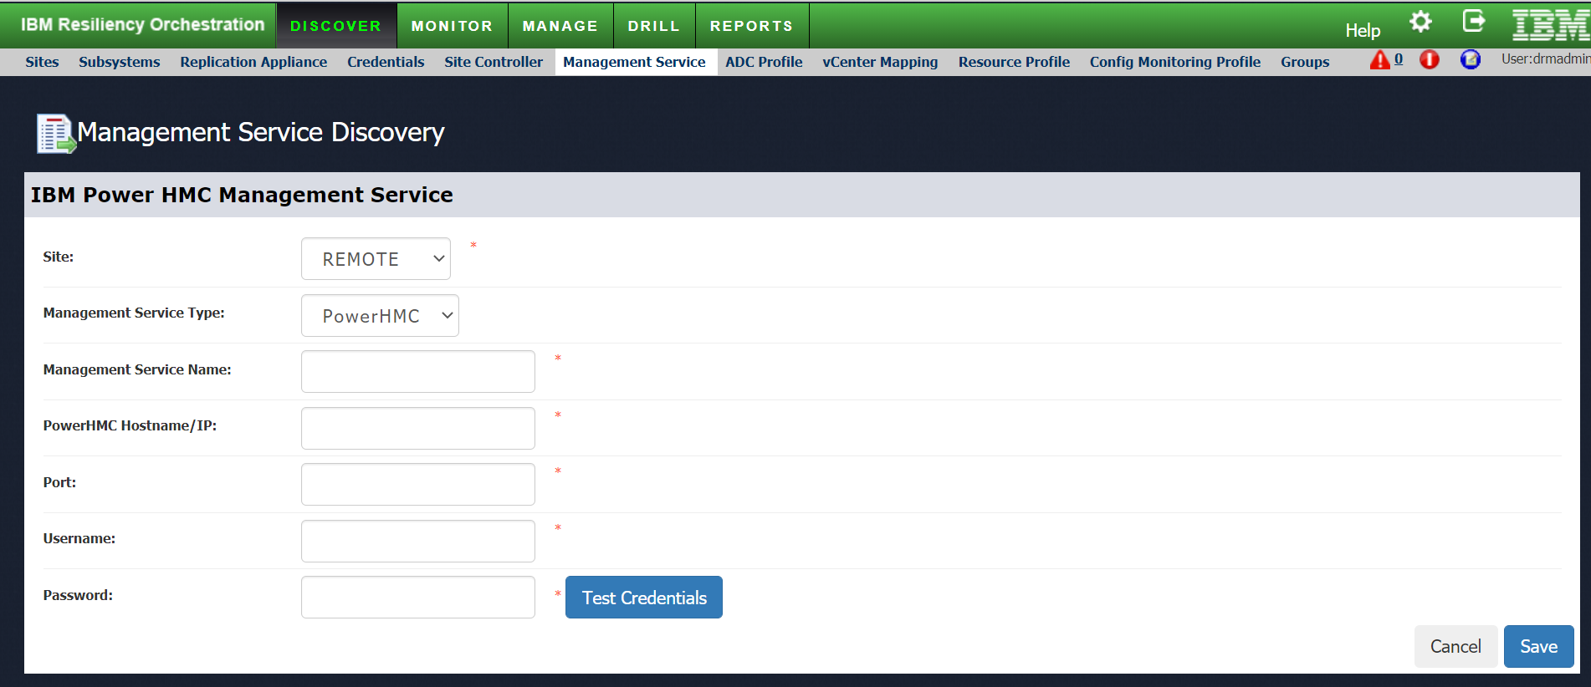

**Management Service Discovery**

Discover the Pcloud management service:

Adding BlockReplicator-V2 management service:

BlockReplicator-V2 management service must be added for connecting it with the IBM Resiliency Orchestration.

To create an AIX Management Service, follow the below procedure.

1. Log in to IBM Resiliency Orchestration.
2. Click **Discover** -> **Management Service** tab. The existing management services, if any, are listed on the **Management Service List** page.
3. Click **Add Management Service** link. The **New Management** **Service** page is displayed.
4. Select a Resiliency Orchestration Sitefrom the Site drop-down list.
5. Select “BLOCKREPLICATOR-V2” as the **Management Service Type as shown in the screenshot below**.

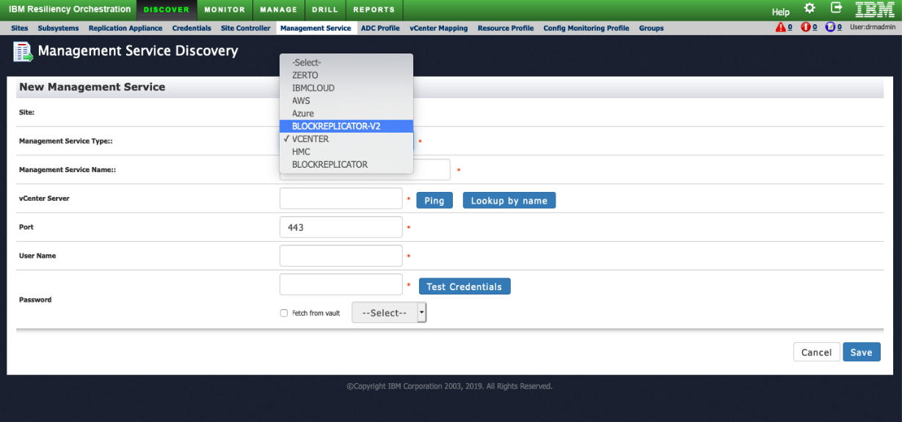

The page refreshes with the relevant fields for creating an AIX Management Service and is as shown in the screenshot below.

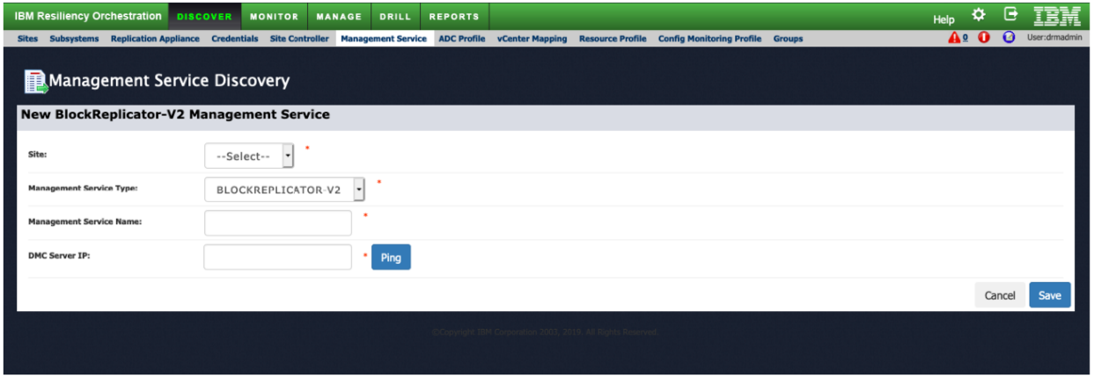

1. Select the Site from the dropdown list.
2. Enter Management Service name and DMC Server IP.
3. Test the connectivity using the Ping button.
4. Click Save.

**Note:** For the remote site:

1. Discover Region, Network (VNET/Subnet/SecurityGroup), Security Group
2. Select AIX MGMTSERVICE > REGION (RAL2, RAL-3)
3. Select Subscription from the list
4. Discover Resource Group in given Region
5. VNET_NAME > SUBNET (RAL-6)
6. SECURITY GROUP (RAL-7)

#### Cloud to Cloud

Discover the following services for primary and remote sites.

**Note:**

You will need to discover AIX Management Service before discovering the Block Replicator V2 Management Service.

1. **IBM PCloud Hostname/IP**: us-<region>.power-iaas.cloud.ibm.com  
   The region depends on the region where the DR LPAR instance is created. Eg. If the LPAR is created in DALLAS then the region will be south. The region can be confirmed by checking the CRN key.  
     
   **Resource CRN Key:** Go to the Cloud.ibm.com UIand click on the resource list. Expand the service and software dropdown and select the region where the DR LPAR instance is created. Copy the CRN value on the right side.

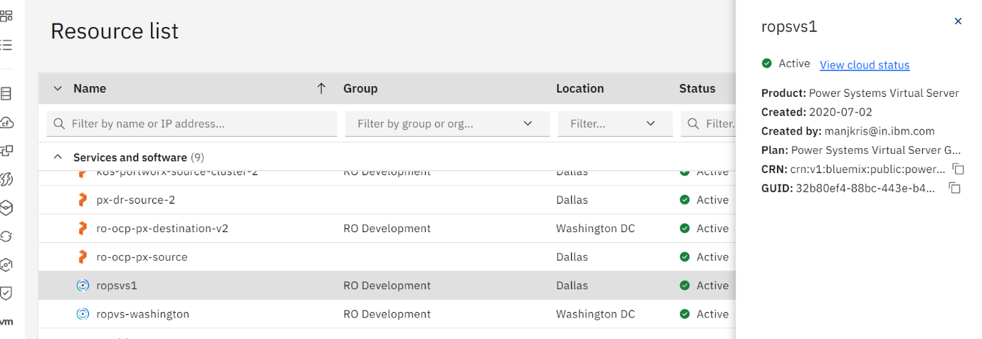

API Key: Go to manage dropdown and select Access (IAM)

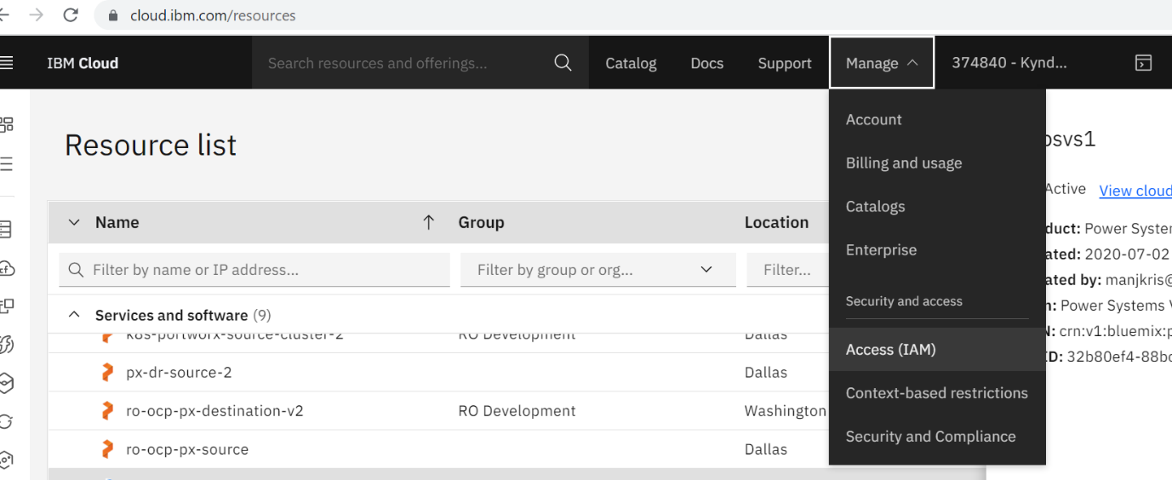

Select API keys and click on create an IBM Cloud API key

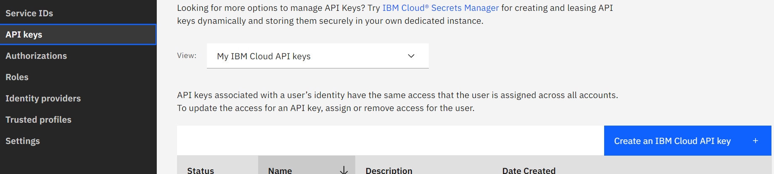

Download the API key created and copy the key generated.

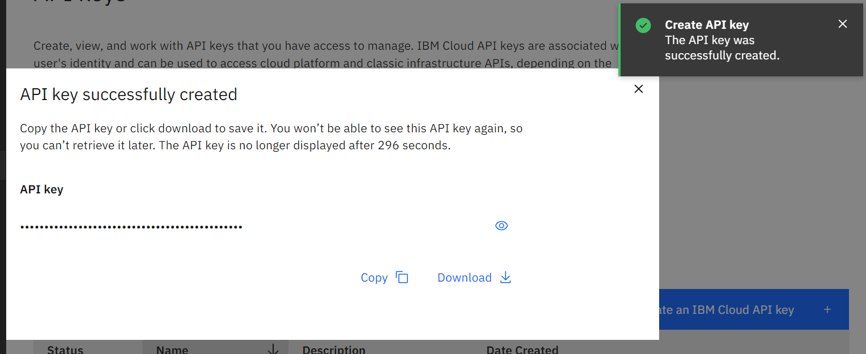

#### Adding AIX management Service

AIX management service must be added to complete the discovery of the AIX cluster.

To create an AIX Management Service, follow the below procedure.

1. Log in to IBM Resiliency Orchestration.
2. Click **Discover** -> **Management Service** tab. The existing management services, if any, are listed on the **Management Service List** page.
3. Click **Add Management Service** link. The **New Management** **Service** page is displayed.
4. Select a Resiliency Orchestration sitefrom the **Site** drop-down list.
5. Select **IBMPCloud** as the **Management Service Type** as shown in the screenshot below.

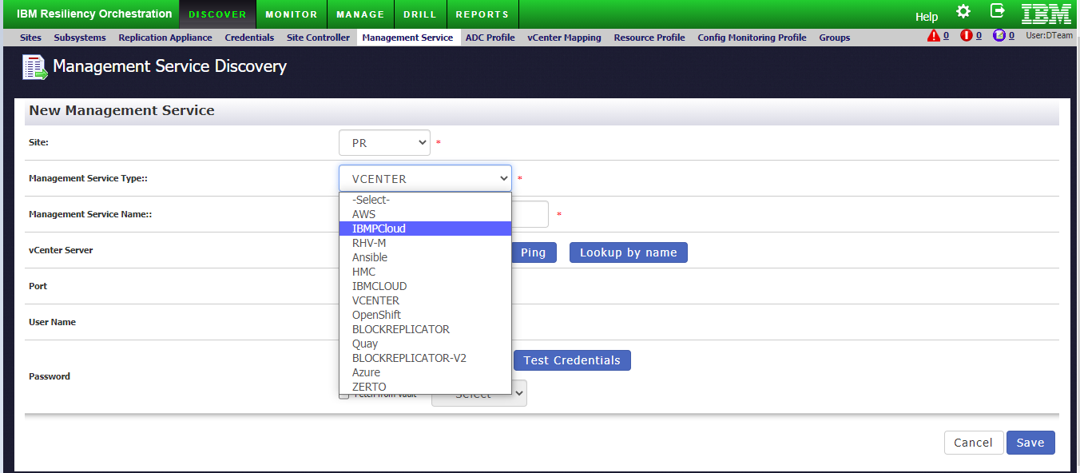

**Note:** The page refreshes with the relevant fields for creating an AIX Management Service and is as shown in the screenshot below.

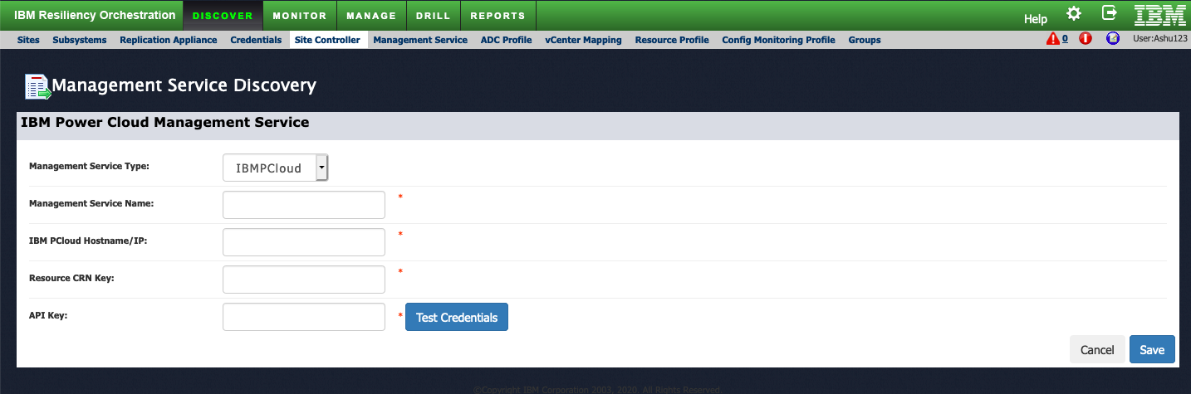

1. Enter the management service name in the **Management Service Name** text box.
2. Enter the IBM pCloud hostname or IP in the **IBM pCloud Hostname/IP** text box.
3. Enter the resource CRN key in the **Resource CRN Key** text box.
4. Enter the API key in the **API Key** text box.
5. Test the credentials and connectivity using the Test Credentials button.
6. Click **Save**.

**Note:** The Management Service for the PR AIX Cluster is created. Repeat the procedure to create a Management Service for a Secondary/Disaster (DR) AIX cluster.

### Viewing AIX Credentials

1. Navigate to the management service page
2. Click on the Management Service name (user-defined) to view the credentials.

### Editing AIX Credentials

1. Navigate to the management service page
2. Click on the edit icon corresponding to the management service name.

**Note:** You can edit the password only.

1. Update the password field, and then click the Save button.
2. OnPrem to Cloud

Applicable as point 2.

1. Cloud to Cloud

Can be validated based on customer request.

### Sites And Subsystem Discovery

#### OnPrem to Cloud & OnPrem to OnPrem

For information on site creation, refer to the Adding Sites topic in the IBM Resiliency Orchestration Administrator’s guide.

A Subsystem comprises Components and Protection Schemes.

**Note:** Component and Protection Scheme will be auto created by the solution

#### Cloud to Cloud

Can be validated based on customer request.

#### OnPrem to Cloud

Can be validated based on customer request.

## Recovery Group

### OnPrem to Cloud

Import the failover workflow for on-prem to cloud from $EAMSROOT/opt/panaces/rpd/solutionPlugins/AIXAgentBasedRBR/ibmclud_cluster_workflow.xml

Import the failover workflow for cluster configuration from $EAMSROOT/opt/panaces/rpd/solutionPlugins/AIXAgentBasedRBR/AIX_Onprem_to_IBMCloud_FOTE.xml

check certified

### Cloud to Cloud

Can be validated based on customer request

### OnPrem to OnPrem

Recovery Group can be done using the JSON file via IBM Resiliency Orchestration Server UI

Upload the JSON file to create a Recovery Group.

**ROOT Volume Recovery Group**   
Use the below mentioned JSON file to create the ROOT Volume recovery group.

$EAMSROOT/rpd/solutionPlugins/AIXAgentBasedRBR/AIXLPAR_GroupCreation_Sample.json

Recovery group creation for Fiber channel config for root disk

$EAMSROOT/rpd/solutionPlugins/AIXAgentBasedRBR/rootvg_disk_sample.json

**Resource Group Recovery Group**

Use the below mentioned JSON file to create a Resource Group, recovery group.

$EAMSROOT/rpd/solutionPlugins/ResourceAIXAgentBasedRBR/AIXLPAR_GroupCreation_Sample.json

Recovery group creation for Fiber channel config for the resource group

$EAMSROOT/rpd/solutionPlugins/ResourceAIXAgentBasedRBR/AIXLPAR_GroupCreation_Sample_cluster.json

**Note:** You will need to copy the sample JSON file and update it before uploading it in the prescribed format.

**Steps to upload via UI:**

1. Go to Discover 🡪 Group
2. Click on the Create Group tab.
3. Browse and upload the JSON file.

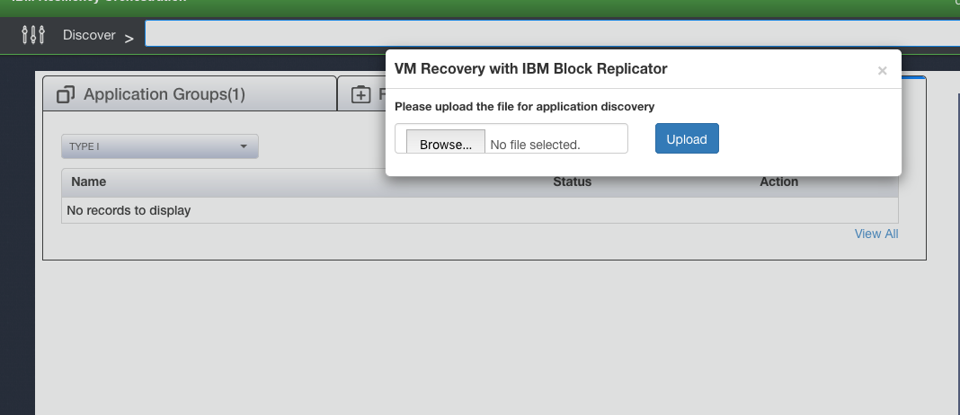

1. After the JSON file is successfully uploaded, the Recovery Group and components will create automatically. All the required workflows will be auto imported and Recovery Group will be listed in the Recovery Group tab.

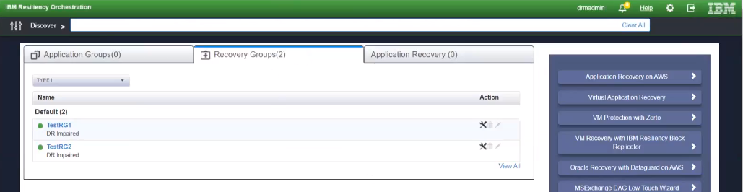

1. Move RG’s continuity state to Normal Inactive.

## Application Group

Guideline to set up an AG.

Let us say the user wants to protect an LPAR that has root disk and data disks and that is being protected as 2 mobility groups. In this case, the ideal thing to do is to create 2 RG for each mobility group and create an AG with these 2 RG's. In this case, the user needs to import workflows located at $EAMSROOT/rpd/solutionPlugins/AIXAgentBasedRBR folder as starting workflow that can be further customized based on need.

Another scenario is when the user wants to protect cluster resources. In this case, cluster resource is 1 MG or more MG depending on the number of cluster resources and one MG for each node of the cluster. We need to create an RG for each of the MG (created automatically as part of JSON import) and then manually create AG for these RG's. We need to import workflow given at location $EAMSROOT/rpd/solutionPlugins/ResourceAIXAgentBasedRBR and customize.

Application Group Creation can be done using manual steps via IBM Resiliency Orchestration Server UI

1. Go to Discover 🡪 Group
2. Click on the Discover Application Group tab.
3. Select the Organization from the dropdown list then click on the Next button.
4. Provide the Application name, Description, Group Priority and select the Recovery groups and move to the right side then click on the Next button.
5. Select the Recovery Groups and arrange in proper recovery order then click on the Next button.
6. Provide the RPO and RTO values then click on the Finish button.

Perform the following steps:

Step1:

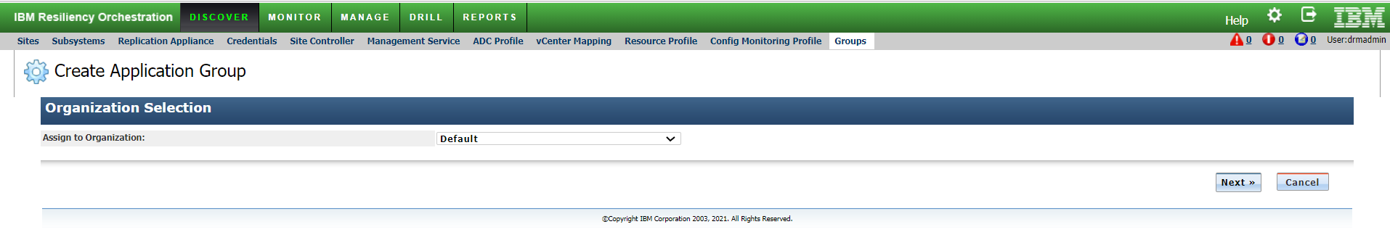

Step2:

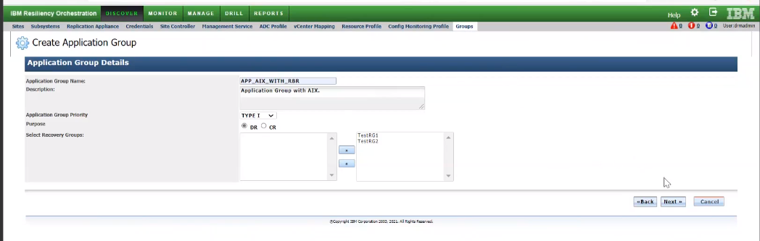

Step3:

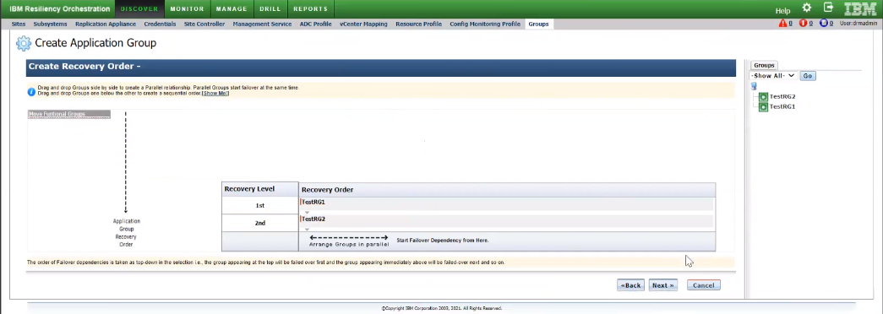

Step4:

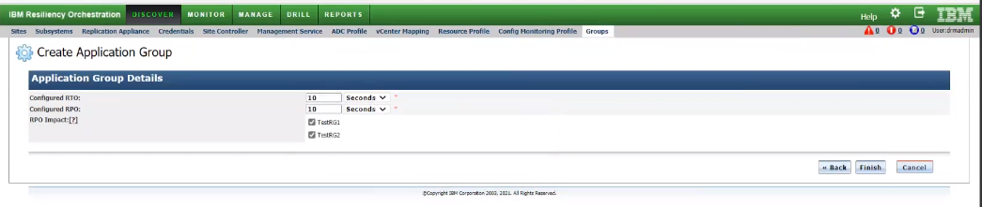

### Group creation for OnPrem to Cloud

The group creation process and steps are the same as OnPrem to OnPrem use case.

## Monitoring

Monitoring includes below three items.

* RPO/RTO Monitoring
* Replication Monitoring

### RPO/RTO Monitoring

Group details and Replication status can be monitored from the Monitor page.

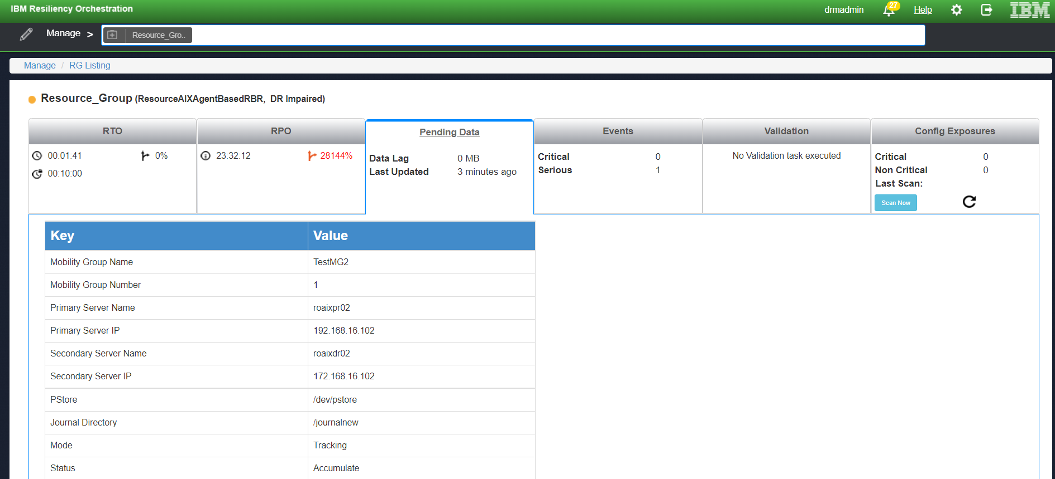

### App RPO

App RPO is not applicable for this solution.

### Data RPO

Data RPO is applicable for this solution.

Get data RPO for the protected LPAR replication Group.

* > stat group

The current RPO field from the command output shows data RPO.

### Recovery Time Objective

RTO is the estimated time required for the secondary/DR site to be up and available in case the primary goes down.

**Note:** Data RPO should be reported for each Recovery Group. Also, it should apply to the Application Group.

### Replication Monitoring

This section corresponds to the “Monitor -> Replication” screen of IBM RO. The table shows the monitored information and how it is obtained. When there is more than one protection manager object involved in the protection then some of these parameters will have to be calculated at each manager object in addition to primary and secondary protection objects.

### Replication Status

Get Replication status for the protected LPAR replication Group using Mobility Group number and domain.

* > stat group
  1. If mode is normal and connected, the group status is ACTIVE
  2. Else the status is NOT complete and updates the status

### Datalag

Cloud-Native RBR provides Data LAG for the protected LPAR based on Replication Mobility Group.

### Stop Replication

* Stop replication for the protected LPAR based on Replication Mobility Group.

connect localhost

select domain $domainName

select server $serverName

select group $groupName

command group killpmd

### Start Replication

* Stop replication for the protected LPAR based on Replication Mobility Group.

connect localhost

select domain $domainName

select server $serverName

select group $groupName

command group launchrefresh

### Replication Detail

Get Replication detail for the protected LPAR based on Replication Mobility Group

connect localhost

select domain $domainName

select server $serverName

select group $groupName

stat group

**Note:** Replication Monitoring should be applicable on AG and RG levels.

Replication info should include the active HACMP Cluster node where the Cluster Resource group is active.

### Events

#### Group Events

This section corresponds to the Events page of IBM Resiliency Orchestration of this solution signature.

|  |  |  |  |  |  |
| --- | --- | --- | --- | --- | --- |
| **Event Id** | **Agent Based RBR Events\*** | **Event Description** | **Impact** | **Severity** | **Polar Event** |
| BCSRBRReplicationInActive | ReplicationInActive | Replication is Inactive | Replication is not in a validated state, Replicated LPAR will not be up to date | CRITICAL | BCSRBRReplicationActive (If mobility group is in normal, Passthru & checkpoint) |
| BCSRBRReplicationActive | ReplicationActive | Replication is Active | Replication is in a Normal state | INFO | BCSRBRReplicationInActive  (If mobility group is in Tracking, Not started & Refresh) |

The following table provides mapping of IBM Resiliency Orchestration event IDs to Agent based RBR events. RBR events are detected by DMC (list event command) and are listed under the “**IBM Resiliency Block Replicator**” category.

## Drills & BCOs

The below steps for drills are based on the current topology which is supported and tested in our lab. End-user steps may vary and the RALs must be developed accordingly based on the customer sequence followed.

We need even to include pre-checks for all the workflows.

**Note:** For Commands or APIs, go through the RALs section.

### Normal Full Copy (NFC)

Not Available in this release.

Pre-requisites:

* AIX LPAR should have RBR Agent installed.
* It should have an additional PStore disk created
* Pstore disk (minimum disk size as supported for allocation for example, 1G or so) should be added in VolumeGroup and Pstore LVOL created (optional, to avoid this re-use for another purpose)
* In the case of HACMP Cluster resource group protection, these are the following requirements and configurations.
  + - additional shared disk (shared across cluster participant nodes) should be allocated for PStore purpose (minimum disk size as supported for allocation for example, 1G or so) per resource group.
    - Additional volume group to be created per resource group for Pstore purpose and the respective Pstore disk needs to be added. The logical volume needs to be created with pre-fix as PStore or pstore-1 and so
    - on. This Pstore Volume group needs to be imported on participant cluster nodes.
    - The respective Pstore VolumeGroup needs to be added to the Cluster Resource group.

**Note:** RBR PStore volume group and respective Pstore disk are required only for RBR group configuration purposes. It’s not protected for replication.

Steps:

* Protect AIX LPAR
* If it’s the part of the HACMP Cluster
  + - plan to protect Cluster participant nodes
    - Plan to protect Resource Groups

### Protect AIX LPAR Cluster nodes

1. Login on AIX prod LPARs to collect disk details for OS disks and related mounted other disks (Not part of Cluster Resource Group)
   * 1. Disk device Name, Size
2. Provision Disks on Staging LPAR via HMC
   * 1. Create disk and attach on DR Staging LPAR via HMC
3. Login on DR Staging LPAR and identify the corresponding Disk Device Name
4. Create RBR Mobility Group
   * 1. Create Mobility Group with source as AIX PROD LPAR and Secondary as DR Staging LPAR
     2. Define PStore device name as allocated on PROD AIX LPAR for OS disks replication
     3. Define Journal file-system detail as available on DR Staging LPAR
     4. Create Replication pair
     5. Save Group
5. Start RBR Mobility Group
6. Start RBR Mobility Group Full Refresh

Perform the same steps for AIX LPAR OS disks protection for all participant cluster nodes.

**Protect Cluster resource groups:**

1. Login on AIX prod LPARs i.e. Cluster Node to collect disk details related to Cluster resource Group.
   * 1. Disk device Name, Size, VolumeGroup

Note: Pstore VolumeGroup doesn’t need to process for protection. The respective logical volume “PStore” is required for RBR Group configuration.

1. Provision Disks on Staging LPAR via HMC
   * 1. Create disk and attach on DR Staging LPAR via HMC
2. Login on DR Staging LPAR and identify the corresponding Disk Device Name

**RBR Group configuration and enable HACMP with RBR:**

1. RBR Mobility Group
   * 1. Connect to DMC and Create Mobility Group with source as AIX PROD LPAR and Secondary as DR Staging LPAR
     2. Update Primary Replication link with Resource Group IP Address.
     3. Define Pstore device name as allocated on PROD AIX LPAR for OS disks replication
     4. Define Journal file-system detail as available on DR Staging LPAR
     5. Create Replication pair
     6. Set group Name as Resource_Group_Name
     7. Save Group
2. Copy RBR Group configuration file (pxxx.cfg) from AIX node to other nodes in the cluster. RBR Group configuration file (pxxx.cfg) location on AIX is as /etc/dtc/lib

**Note:** Verify this Group configuration file and make changes for the protected source disks if the corresponding disk device name is different on other nodes.

**Note:** Update the Primary HOST IP as static IP of the respective node inside the config file.

1. Repeat the above steps for all resource groups in the same cluster as required for protection.
2. Building RBR Configuration for HACMP Cluster Resource Group:
   * 1. Start with the node where the resource group is running or plan for resource group failover to the node where configuration needs to start.
     2. Connect to DMC collector and import the configuration file from other nodes in the cluster that do not have Mobility Group for the same resource Group.
        + 1. Select the server and issue the command “import server” to import the mobility group.
          2. Repeat this procedure on all other nodes in the cluster.

**Note:** After every import mobility group to each server, Update the primary replication link as shared IP.

1. Activate RBR group config with HACMP cluster
   * 1. Run dtcmodhacmp resource_group1:<group#> [resource_group2:<group#>] on each node in the cluster.

Where:

resource_group is the HACMP resource group that needs to be replicated.

<group#> is the Mobility Group which has all of the volumes associated with the resource groups.

for example, one resource group: dtcmodhacmp rsgrp1:0

multiple resource groups: dtcmodhacmp rsgrp1:5 rsgrp2:6

1. Move the resource groups away from the node to be RBR HACMP enabled
2. Activate RBR HACMP scripts.
   * + 1. Type: cd /usr/es/sbin/cluster/events/utils
       2. Backup original cl_activate_vgs and cl_deactivate_vgs scripts using the following commands:
          1. Type: cp -p cl_activate_vgs cl_activate_vgs_original
          2. Type: cp -p cl_deactivate_vgs cl_deactivate_vgs_original
       3. Move in the new cl_activate_vgs and cl_deactivate_vgs scripts using the following commands:
          1. Type: mv cl_activate_vgs.dtc cl_activate_vgs
          2. Type: mv cl_deactivate_vgs.dtc cl_deactivate_vgs
       4. Bring the resource groups back online to the RBR HACMP enabled node.
3. Type dtcinfo to validate that the replicated devices have started.
4. Repeat the procedure 8 (ii) to 8 (iv) for the remaining nodes in the cluster
5. Test moving the resource group between nodes. When the resource group is moved from node to node, type dtcinfo on the new node to ensure that the replicated devices are present and operational.

**RBR Group configuration setup completed.**

1. Connect to DMC and Start RBR Mobility Group using Active Cluster node as RBR Group primary server where resource group is running.
2. Start Full Refresh
3. Wait for Sync and update CRO Group status.

### Normal Copy

Reverse Normal Copy

### Drills

#### Switchover/Switchback:

Not supported in this release

#### Failover Test Exercise:

FOTE Workflow needs to be customized before execution.

#### LPAR RG FOTE Steps:

**\* PreFOTE:**

1. Click on discover>Recovery Groups>Recovery Group>Drill.

2. Go to $EAMSROOT/rpd/solutionPlugins/AixClusterWithTDMF/ AIX_LPAR_FOTE.xml and download AIX_LPAR_FOTE.xml

3. Edit the existing Failover Test exercise workflow and import the AIX_LPAR_FOTE.xml, then save and publish the workflow.

**PostFOTE:**

1. Click on discover>Recovery Groups>Recovery Group>Drill.

2. Create one dummy workflow with the name PostFOTE.

3. Go to $EAMSROOT/ rpd/solutionPlugins/AixClusterWithTDMF/ AIX_LPAR_POST_FOTE.xml and download AIX_LPAR_POST_FOTE.xml

4. Edit the newly created PostFOTE workflow and import the AIX_LPAR_POST_FOTE.xml then save and publish the workflow.

**Resource Group RG FOTE Steps:**

**\* PreFOTE:**

1. Click on discover>Recovery Groups>Recovery Group>Drill.

2. Go to $EAMSROOT/rpd/solutionPlugins//AixResourcegroupWithTDMF/ AIX_RESOURCE_FOTE.xml and download AIX_RESOURCE_FOTE.xml

3. Edit the existing Failover Test exercise workflow and import the AIX_RESOURCE_FOTE.xml, then save and publish the workflow.

**PostFOTE:**

1. Click on discover>Recovery Groups>Recovery Group>Drill.

2. Create one dummy workflow with the name PostFOTE.

3. Go to $EAMSROOT/ rpd/solutionPlugins//AixResourcegroupWithTDMF/AIX_RESOURCE_POST_FOTE.xml  
and download AIX_RESOURCE_POST_FOTE.xml

4. Edit the newly created PostFOTE workflow and import the AIX_RESOURCE_POST_FOTE.xml then save and publish the workflow

**AG level workflow:**

A system does not generate AG-level workflow. Users must stitch the AG level workflow manually.

Setup Steps-

1. Stitch the AG level workflow manually using “FORK”, “JOIN” and TE/BCO action.

2. Publish and execute.

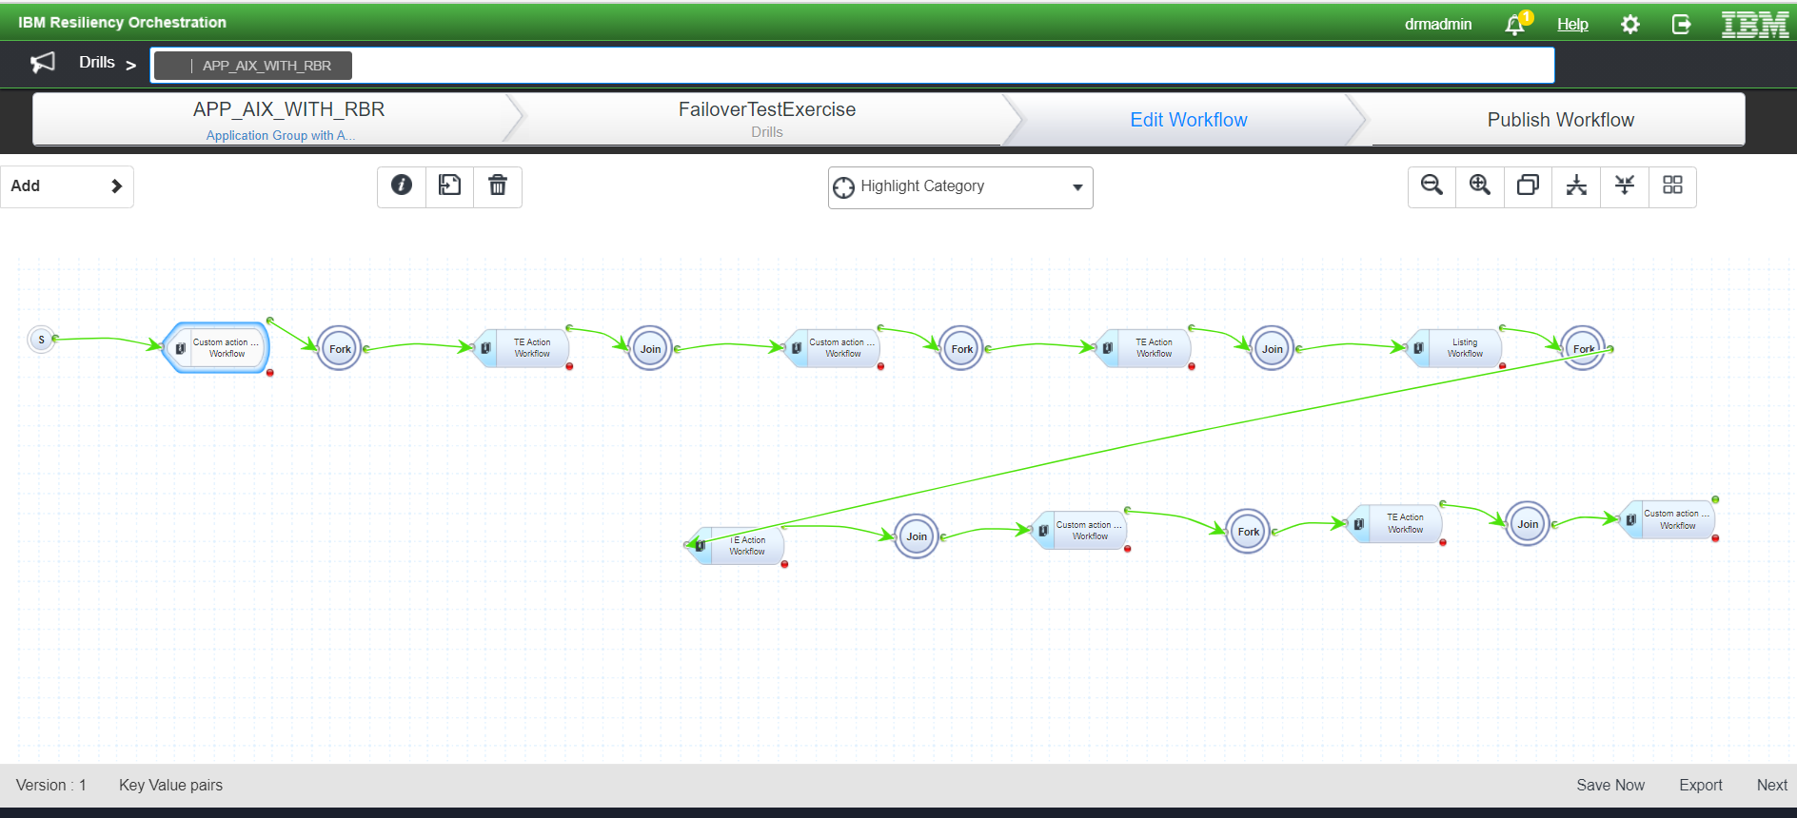

**LPAR FOTE**

Pre FOTE Steps:

1. Generate Key values for Workflow execution.

2. IBR Check Replication Status.

3. Enable IBR Checkpoint.

4. Disk snapshot clone.

5. Disable IBR Checkpoint.

6. Find the SA slots.

7. Find the vHosts.

8. Find the backing device.

9. Create LPAR using SSH.

10. Create Network Adapter for LPAR.

11. Find a free slot from the VIOS server.

12. Create Server SCSI Adapter.

13. Create client SCSI Adapter.

14. Define the disk operation.

15. Detach Replicated Disk.

16. Map Replicated Disk.

17. Save AG Level Key values.

18. Save Run time Key Values.

Post FOTE:

1. Detach Replicated Disk

2. MapReplicatedDiskToSA

3. Delete LPAR and VIOS-Server Adapters

**Resource FOTE**

Pre FOTE Steps:

1. Generate Key values for Workflow execution.

2. Load AG level KV

3. IBR Check Replication Status.

4. Enable IBR Checkpoint.

5. Disk snapshot clone.

6. Disable IBR Checkpoint.

7. Find the SA slots.

8. Find the vHosts.

9. Find the backing device.

10. Define the disk operation.

11. Detach Replicated Disk.

12. Map Replicated Disk.

13. Activate LPAR

14. Save Run time Key Values.

Post FOTE:

1. ShutdownLPARUsingSSH

2.DetachReplicatedDisk

3. MapReplicatedDiskToSA

#### FOTE steps for Fiber channel Config :

1. Assign Action
2. Check Available Memory
3. Check Available Processing Units
4. Get Memory Region Size
5. Create NIC command
6. Create LPAR Using SSH
7. Create Network Adapter for LPAR
8. Get VIOS Profile name
9. Find Free Slot From VIOS server
10. Create Server FC Adapter
11. Create Client FC Adapter
12. Find VFC Adapter
13. Find FC Adapter
14. Map-Server Virtual FC Adapter With Physical FC Adapter
15. Get WWPN number
16. Find SVM
17. Find Vols from cluster
18. EnableIBRCheckPoint
19. Clone Volume
20. DisableIBRCheckPoint
21. Create iGroup
22. Find LUNs
23. Map LUNs
24. Activate LPAR
25. Save KV
26. Save Run Time Key Values

PostFOTE Steps

1. Shutdown LPAR Using SSH
2. Unmap DR LUNs
3. Delete iGroup
4. DR Volume offline
5. Delete Volume offline
6. Delete vfc map
7. Delete vfc slot
8. Delete DR LPAR

#### FOTE Steps for IBM Cloud to IBM Cloud:

FOTE Steps:

1. CreateDRVmWithSelectedImage
2. CheckRplStatus
3. EnableReplCheckpoint
4. CloneReplicatedOSDisk
5. CloneReplicatedDataDisks
6. DisableReplCheckpoint
7. GetDRVmRootVolInfo
8. StopDRVm
9. CreateTempDisk
10. MakeTempDiskBootable
11. SetClonedOsDiskBootable
12. AttachTempDiskToDRVm
13. AttachClonedDataDisksToDRVm
14. SetTempDiskAsDRVmBootDisk
15. DetachDRVmRootDisk
16. AttachClonedOSdisk
17. DeleteDetachedRootDisk
18. SetBootClonedOsDisk
19. DetachTempDisk
20. DeleteTempDisk
21. StartDRVm
22. GetDRVmDetails
23. DeleteDRVm
24. DeleteClonedDataDisk

#### FOTE Workflow On-Prem to the Cloud:

1. Create the mobility group with the boot and data disks and start the replication.
2. Add the correct values in the JSON file of the mobility and create the RG.
3. Monitor the status of the group from the RO Monitor page after selecting the RG added above.

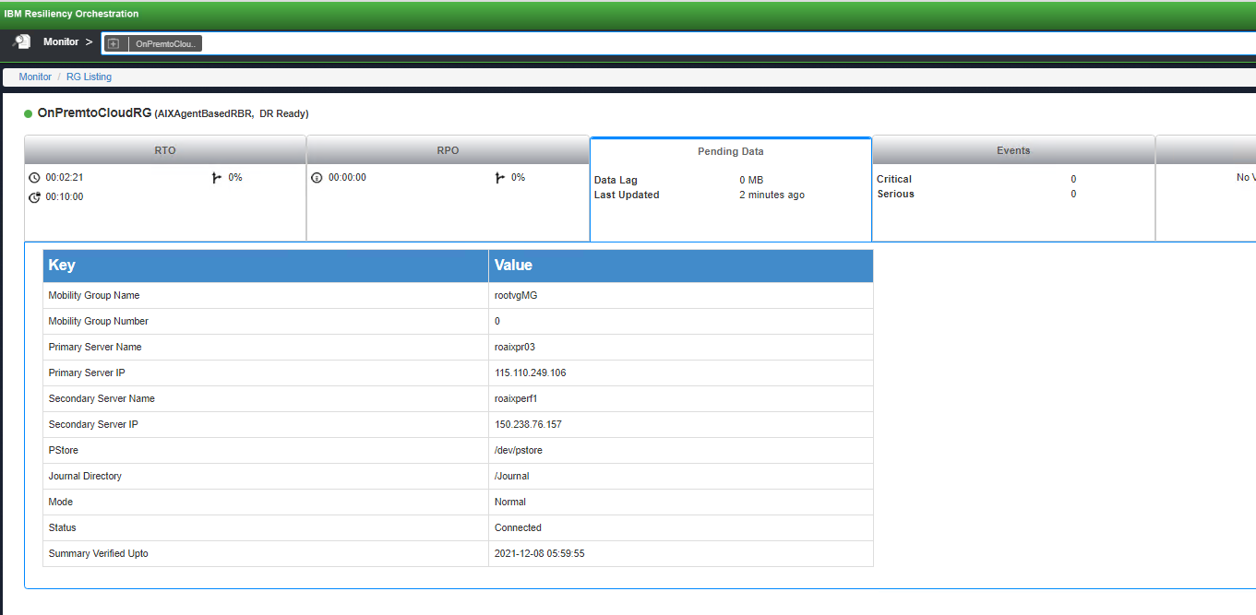

1. After the groups are in the normal state, go to the Drill page and go to the Summary tab and select Recovery Groups in the dropdown menu and select the cluster configured RG.

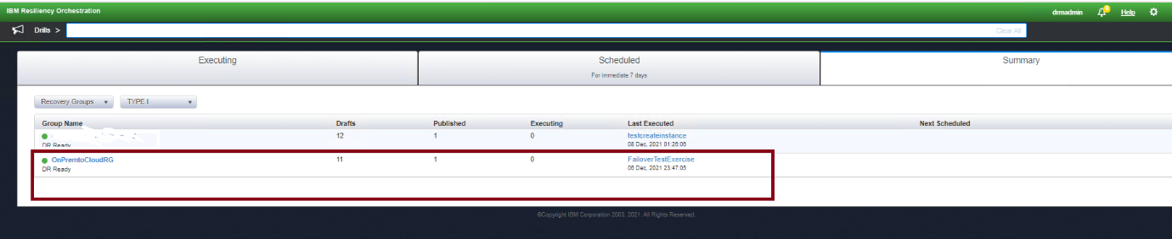

1. On the Drill page for the selected RG, edit the FailoverTestExercise workflow.  
   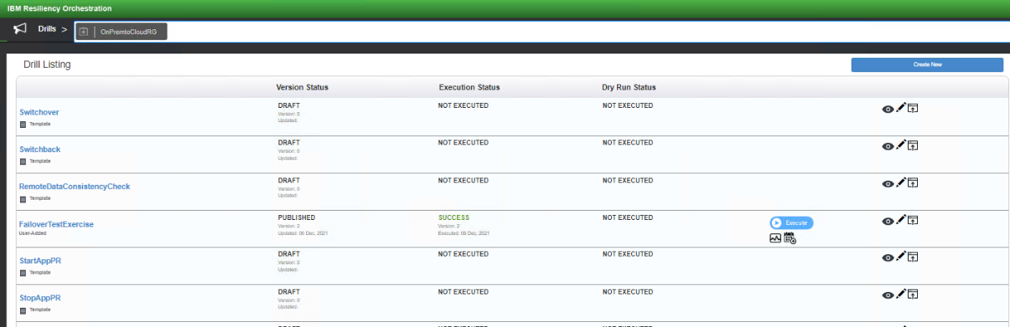
2. Import the failover workflow for on-prem to cloud from $EAMSROOT/opt/panaces/rpd/solutionPlugins/AIXAgentBasedRBR/ibmclud_cluster_workflow.xml

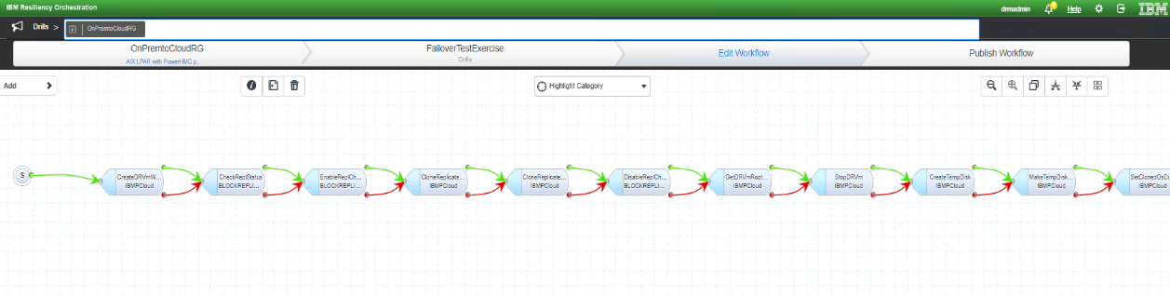

1. Go to the next page and enter the key-value pair for the SA disks with the correct replicated data disk and the root disk as below:

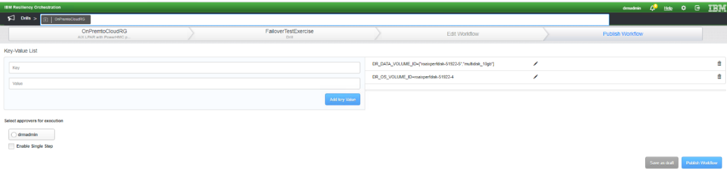

Now publish the workflow and start the FOTE execution.  
  
FOTE Workflow Steps:

1. CreateDRVmWithSelectedImage
2. CheckReplStatus
3. EnableReplCheckpoint
4. CloneReplicatedOSDisk
5. CloneReplicatedDataDisks
6. DisableReplCheckpoint
7. GetDRVmRootVolInfo
8. StopDRVm
9. CreateTempDisk
10. MakeTempDiskBootable
11. SetClonedOsDiskBootable
12. AttachTempDiskToDRVm
13. AttachClonedDataDisksToDRVm
14. SetTempDiskAsDRVmBootDisk
15. DetachDRVmRootDisk
16. AttachClonedOSdisk
17. DeleteDetachedRootDisk
18. SetBootClonedOsDisk
19. DetachTempDisk
20. DeleteTempDisk
21. StartDRVm
22. GetDRVmDetails
23. DeleteDRVm
24. DeleteClonedDataDisk

#### FOTE Workflow Cluster OnPrem to Cloud:

1. Create the mobility group with the shared cluster disk and start replication. Create another group with the boot disk of one of the cluster nodes and start the replication on that as well.
2. Add the correct values in the JSON file of the mobility group that has the shared disk and create the RG. Optionally add the RG for the MG with the root disk replication pair.
3. Monitor the status of the group from the RO Monitor page after selecting the RG added above.   
   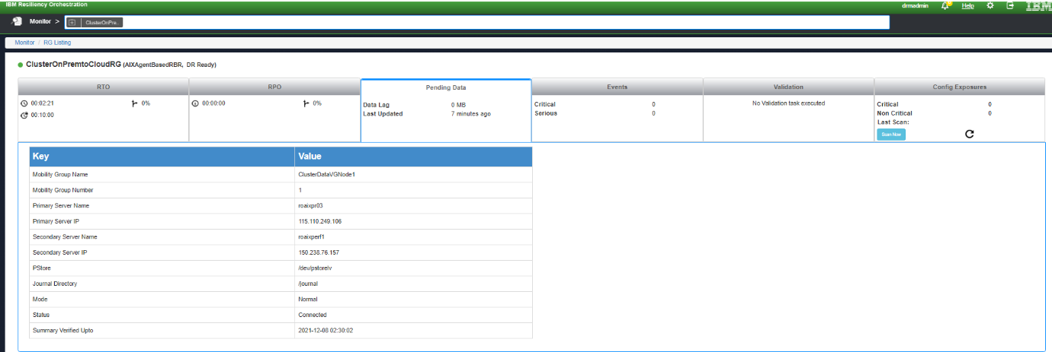
4. After the groups are in the normal state, go to the Drill page and go to the Summary tab and select Recovery Groups in the dropdown menu and select the cluster configured RG.

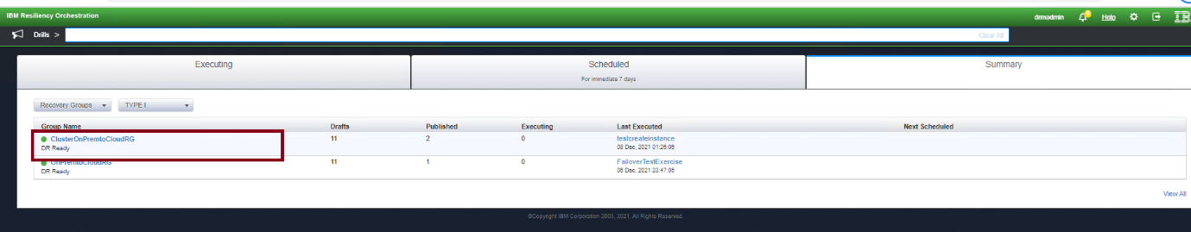

1. On the Drill page for the selected RG, edit the FailoverTestExercise workflow.

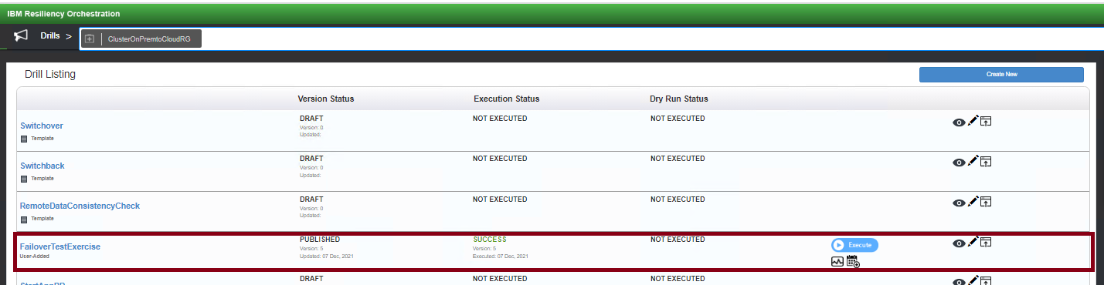

1. Import the failover workflow for cluster configuration from $EAMSROOT/opt/panaces/rpd/solutionPlugins/AIXAgentBasedRBR/AIX_Onprem_to_IBMCloud_FOTE.xml
2. For cluster Fote, we need to add two additional RALs have been added where we need to enter the details of the root MG. Click on the second EnableReplCheckpoint RAl and go to ActionProperties and add the correct values related to the root MG.

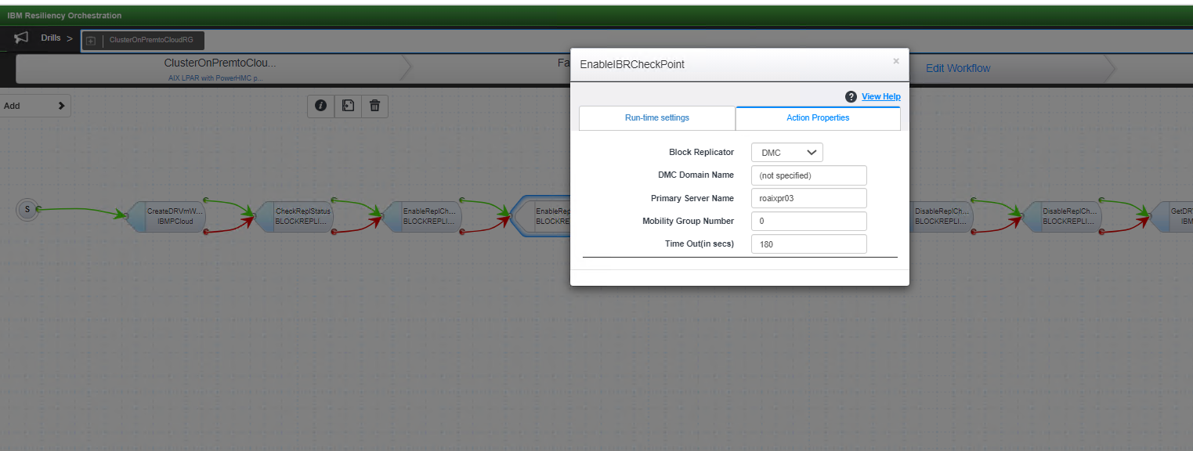

1. Do the same for the second DisableReplCheckpoint RAL and save the workflow.
2. Go to the next page and enter the key-value pair for the SA disks with the correct replicated data disk (cluster disk on PR) and the root disk.   
   Note- If the root MG has other data disks then we can add them also here with the format as below:  
   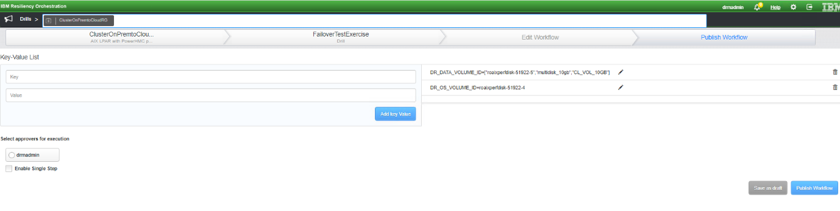

Now publish the workflow and start the FOTE execution.  
  
FOTE Steps:  
  
1.CreateDRVmWithSelectedImage

2.CheckReplStatus

3.EnableReplCheckpoint

4.EnableReplCheckpoint

5.CloneReplicatedOSDisk

6.CloneReplicatedDataDisks

7.DisableReplCheckpoint

8.DisableReplCheckpoint

9.GetDRVmRootVolInfo

10.StopDRVm

11.CreateTempDisk

12.MakeTempDiskBootable

13.SetClonedOsDiskBootable

14.AttachTempDiskToDRVm

15.AttachClonedDataDisksToDRVm

16.SetTempDiskAsDRVmBootDisk

17.DetachDRVmRootDisk

18.AttachClonedOSdisk

19.DeleteDetachedRootDisk

20.SetBootClonedOsDisk

21.DetachTempDisk

22.DeleteTempDisk

23.StartDRVm

24.GetDRVmDetails

25.DeleteDRVm

26.DeleteClonedDataDisk

### BCO

#### Failover

Failover Workflow needs to be customized before execution.

AG level workflow:  
A system does not generate AG-level workflow. Users must stitch the AG level workflow manually.  
Setup Steps-

1. Stitch the AG level workflow manually using “FORK”, “JOIN” and TE/BCO action.  
2. Publish and execute.



FOTE Steps:

1. Generate Key values for Workflow execution.

2. IBR Check Replication Status.

3. Agent-based RBR failover

4. Disk snapshot clone.

5. Find the SA slots.

6. Find the vHosts.

7. Find the backing device.

8. Create LPAR using SSH.

9. Create Network Adapter for LPAR.

10. Find a free slot from the VIOS server.

11. Create Server SCSI Adapter.

12. Create client SCSI Adapter.

13. Define the disk operation.

14. Detach Replicated Disk.

15. Map Replicated Disk.

16. Save AG Level Key values.

17. Save Run time Key Values.

#### FO OnPrem to Cloud Cluster:

1. Create the mobility group with the shared cluster disk and start replication. Create another group with the boot disk of one of the cluster nodes and start the replication on that as well.
2. Add the correct values in the JSON file of the mobility group that has the shared disk and create the RG. Optionally add the RG for the MG with the root disk replication pair.
3. Monitor the status of the group from RO Monitor page after selecting the RG added above.   
   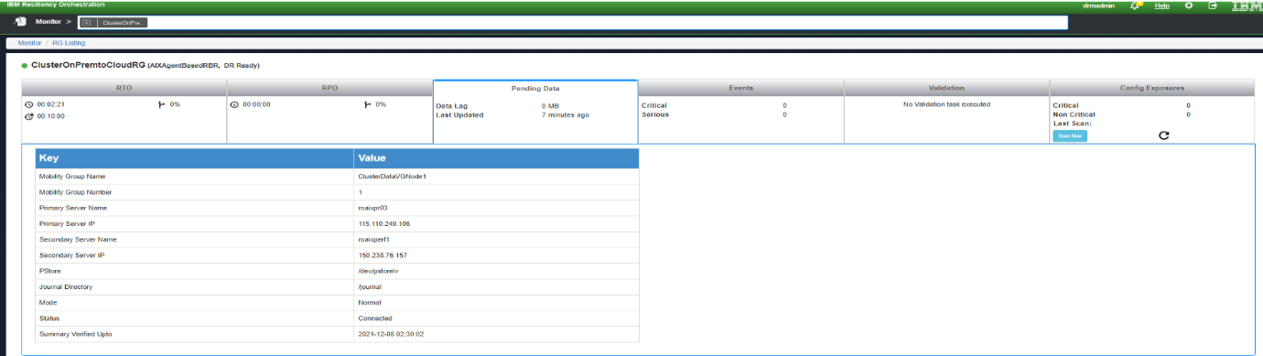
4. After the groups is in normal state, goto manage and select the RG.  
   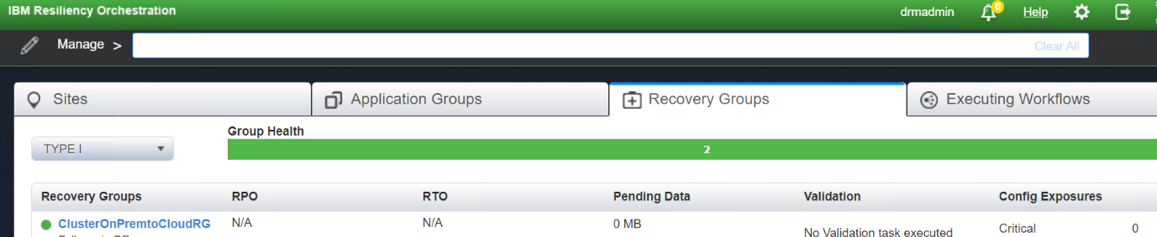
5. Go to the ‘Continuity Workflows’ section and select ‘View all workflows ‘. Edit the Failover workflow. Download the failover xml file from RO cli path $EAMSROOT/rpd/solutionPlugins/AIXAgentBasedRBR/ibm_cloud_cluster_fo.xml and import the new workflow.  
   Here, we will add an additional step to monitor the AIX LPAR creation. Click on ‘Add’ and select IBMPcloud and click on the add button for ‘GetInstanceStatus’.  
     
   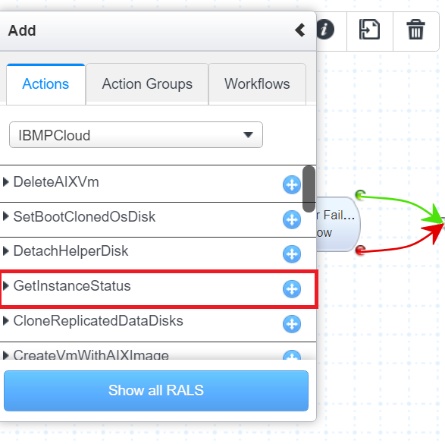

Place the newly added RAL as the second RAL. Select the RAL and click on the ‘Retry on Failure’ checkbox and add a retry count of 60.  
  
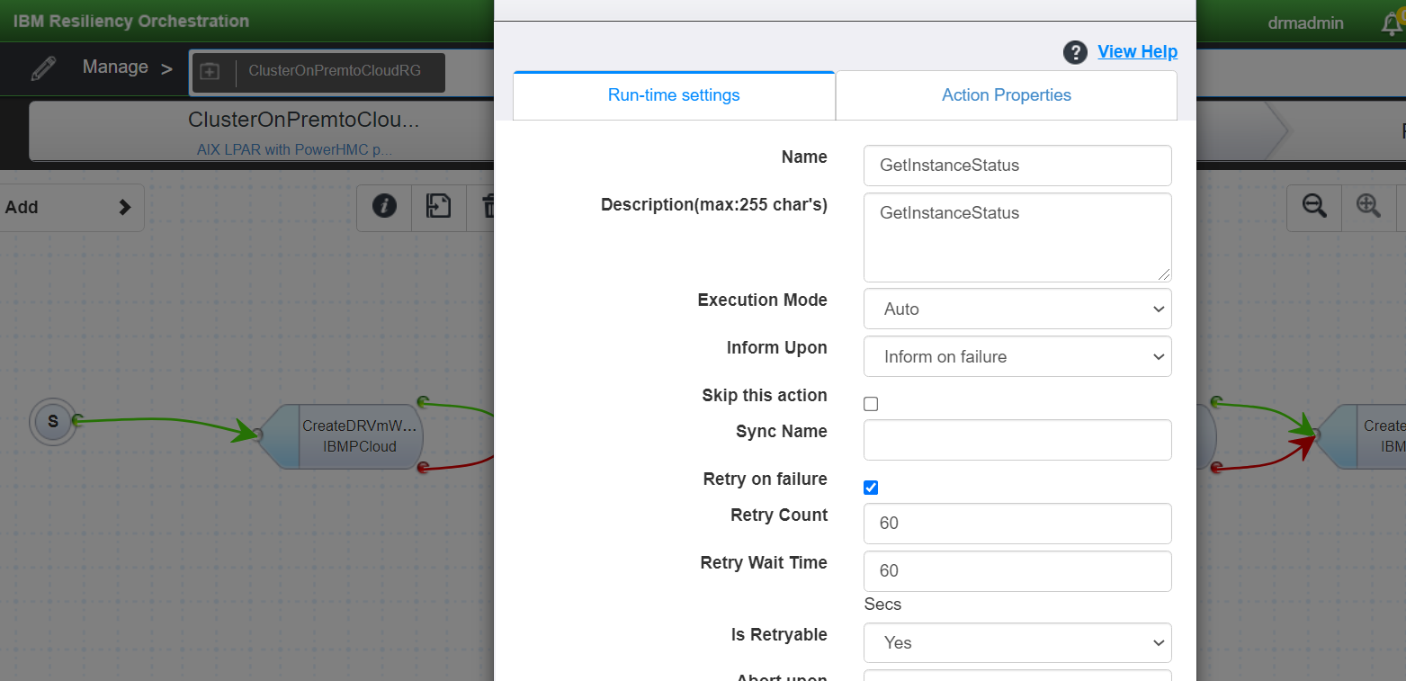  
  
Save the workflow and go to the next page and add the disks of both the groups and publish the workflow. After publishing the workflow start the execution of the workflow.  
  
FO Steps:

|  |
| --- |
| 1. CreateDRVmWithSelectedImage 2. GetInstanceStatus |
| 1. GetDRVmRootVolInfo |
| 1. StopDRVm |
| 1. CreateTempDisk |
| 1. MakeTempDiskBootable |
| 1. CheckReplStatus |
| 1. TDMF failover |
| 1. TDMF failover |
| 1. CloneReplicatedOSDisk |
| 1. CloneReplicatedDataDisks |
| 1. SetClonedOsDiskBootable |
| 1. AttachTempDiskToDRVm |
| 1. AttachClonedDataDisksToDRVm |
| 1. SetTempDiskAsDRVmBootDisk |
| 1. DetachDRVmRootDisk |
| 1. AttachClonedOSdisk |
| 1. DeleteDetachedRootDisk |
| 1. SetBootClonedOsDisk |
| 1. DetachTempDisk |
| 1. DeleteTempDisk |
| 1. StartDRVm |
| 1. GetDRVmDetails |

#### Fallback :

HACMP Cluster protection FALLBACK is currently not supported.

Prerequisites:

* IBM Power HMC service and credentials,
* Power Server name,
* DR LPAR/LPAR details,
* PR Staging LPAR/LPAR,
* Replicated Disk details (disk name, size, unique device ID),
* DMC Management Service,
* Replication OS level Disk detail (disk name, size, unique device ID),
* IBM Power Server Network details (Virtual Switch UUID, ID, VLAN ID),
* Processor type and numbers (Min, Max, and desired VP and PU’s),
* Memory details (Min, Max, and desired memory size in MB)

Assuming Storage Setup are same for Primary and Target Site.

Perform the following steps:

Step1:

Set new/DRLPAR IP to the Agent based RBR on the FO LPAR (OS level command)

./dtcagentset -i 192.168.20.112

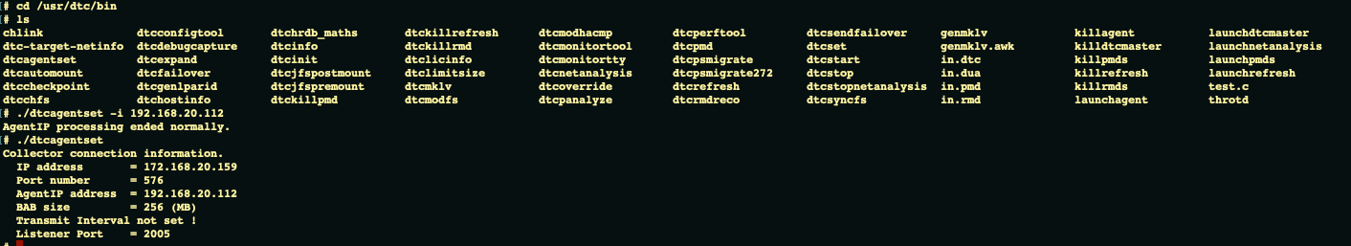

Step2:

Rename the old group config file -- Rename PR to DR mobility group config file to a temp_<config file name> (the PR to DRSALPAR MG group)

mv /etc/dtc/lib/p000.cfg /etc/dtc/lib/temp_p000.cfg

Step3:

Stop Agent based RBR agent on the PRLPAR

./killdtcmaster

./killagent

Step4:

Start the Agent based RBR on FO LPAR

./launchdtcmaster

./launchagent

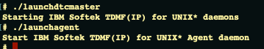

Step5:

Run reco on DMC for DRSALPAR for PRLPAR to DRSALPAR MG.

On DMC

-- connect localhost

-- Select domain (not specified)

-- select server <DR SALPAR>

DMC>command server reco -g 0 -d

Step6:

Create virtual disk for Pstore on DR VIOS

Pstore_FOLPAR_disk (size 1GB)

https://192.168.1.99:443/rest/api/uom/VirtualIOServer/05EBC80B-E35B-49C5-9896-B09C3D9A3457/VolumeGroup/c9081d9f-d927-3019-bae0-686aa0d952f3

Step7:

Attach Pstore disk to DR LPAR (FO LPAR)

Pstore_FOLPAR_disk (size 1GB)

https://192.168.1.99:443/rest/api/uom/VirtualIOServer/05EBC80B-E35B-49C5-9896-B09C3D9A3457/

Step8:

Create VG and logical volume from the Pstore disk on DR LPAR

# lspv

hdisk4 00fb71d5fc53f925 rootvg active

hdisk5 00fb71d517f6c935 vgtdmf active

hdisk6 none

# mkvg -y PstoreVG -s32 hdisk6

0516-1254 mkvg: Changing the PVID in the ODM.

PstoreVG

# mklv -y PstoreLV -t jfs2 PstoreVG 1

PstoreLV

# mklv -y loglv02 -t jfs2log PstoreVG 1

0516-360 getlvname: The device name is already used; choose a

different name.

0516-822 mklv: Unable to create logical volume.

# lsvg -l PstoreVG

PstoreVG:

LV NAME TYPE LPs PPs PVs LV STATE MOUNT POINT

PstoreLV jfs2 1 1 1 closed/syncd N/A

# ls -l /dev/PstoreLV

brw-rw---- 1 root system 41, 1 Feb 09 09:47 /dev/PstoreLV

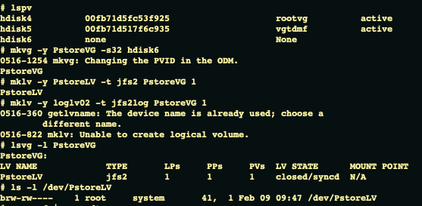

/dev/PstoreLV is the pstore

Step9:

Validate DR LPAR Agent based RBR registration status on DMC (Online status should be YES)

On DMC

-- Connect localhost

-- Select domain (not specified)

-- list server -v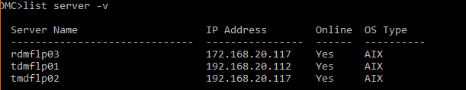

Step10:

Validate PR SALPAR availability on DMC (Online status should be YES)

On DMC

-- Connect localhost

-- Select domain (not specified)

-- list server -v

Step11:

Identify the disk requirements from DR LPAR or MG (number of Disks and Size of the disks)

The disk details will be captured as part of RG discovery where PR disks names, sizes will be available and can be used as input to create the disks required on PR VIOS.

Step12:

Create virtual disks on PR VIOS (based on details identified in step 11)

https://192.168.1.99:443/rest/api/uom/VirtualIOServer/05EBC80B-E35B-49C5-9896-B09C3D9A3457/VolumeGroup/c9081d9f-d927-3019-bae0-686aa0d952f3

Step13:

Attach created virtual disks to PR SALPAR

Data_tdmf2

tdmflpar1_lv

https://192.168.1.99:443/rest/api/uom/VirtualIOServer/05EBC80B-E35B-49C5-9896-B09C3D9A3457/

POST call with full rest body and the modified VritualSCSIMapping content

Step14:

Get disk unique identifier and path (/dev/rhdisk0 etc) info from PR SALPAR & store in RO - for identifying the disk irrespective of changes to the path or other info during attaching and detach operations etc.

The option is to use disk Unique device ID and match the value with the lspv -u command output from OS and find the unique device ID. Populate the relevant hdisk value as outkey. This will be performed for both PR and DR disks and will be used by refresh devices DMC RAL to create replication pair info.

Step15:

Create mobility group with Pstore and journal

On DMC

-- connect localhost

-- Select domain (not specified)

-- Select server <DRLPAR IP address>

-- add group -t <PRSA LPAR>

-- set group pstoredirectory </dev/lvname>

-- set group journal yes

-- set group journaldirectory </journal>

-- save group

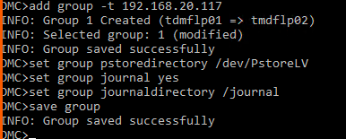

Step16:

List devise on FO LPAR

On DMC

-- connect localhost

-- Select domain (not specified)

-- Select server <DRLPAR IP address>

-- list device -v

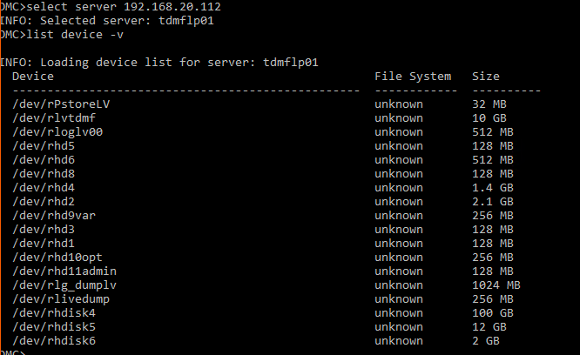

Step17:

List Device on PR SALPAR

On DMC

-- connect localhost

-- Select domain (not specified)

-- Select server <PRSA LPAR IP address>

-- list device -v

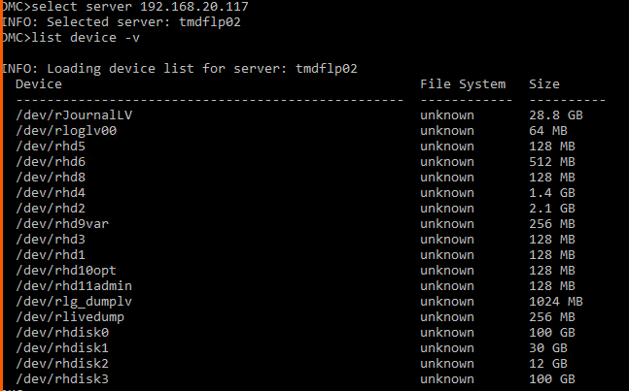

Step18:

Add replication Pair(s)

On DMC

-- Select domain

-- Select server <DRLPAR IP address>

-- select group <group number>

DMC>add pair /dev/rhdisk0 /dev/rhdisk3

INFO: Pair Created

INFO: Selected pair: /dev/rhdisk0 => /dev/rhdisk3 (modified)

DMC>add pair /dev/rhdisk1 /dev/rhdisk1

INFO: Pair Created

INFO: Selected pair: /dev/rhdisk1 => /dev/rhdisk1 (modified)

DMC>save group

INFO: Group saved successfully

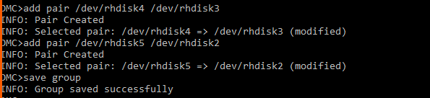

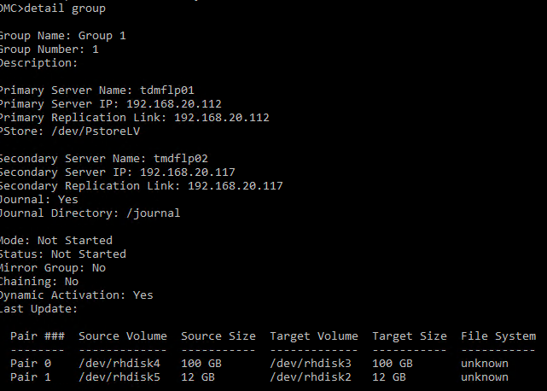

Step19:

Start Mobility group

On DMC

-- connect localhost

-- Select domain (not specified)

-- Select server <DRLPAR IP address>

-- select group <group number>

-- command group start



Step20:

Verify group to be Passthru and accumulate

On DMC

-- connect localhost

-- Select domain (not specified)

-- Select server <DRLPAR IP address>

-- select group <group number>

-- detail group

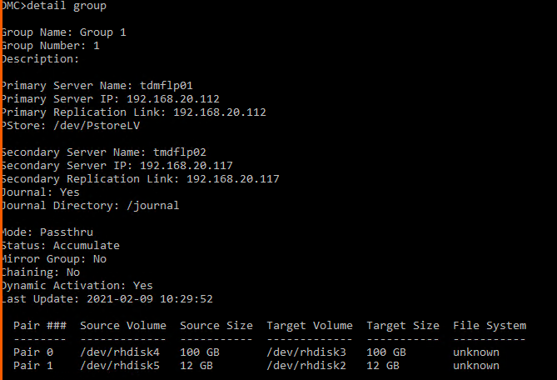

Step21:

Launch full refresh

On DMC

-- connect localhost

-- Select domain (not specified)

-- Select server <DRLPAR IP address>

-- select group <group number>

-- command group launchrefresh -f

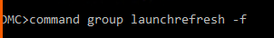

Step22:

Check replication status to become Normal

-- Select domain

-- Select server <DRLPAR IP>

-- select group <mg number>

-- stat group

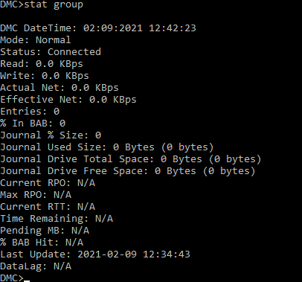

Step23:

Set new IP to Agent based RBR - [dtcagentset -i <PRLPAR IP address>] on DRLPAR (FO LPAR)

./dtcagentset -i <192.168.20.112>

Step24:

Rename the old MG config file name to original name from temp.

mv /etc/dtc/lib/temp_p000.cfg /etc/dtc/lib/p000.cfg

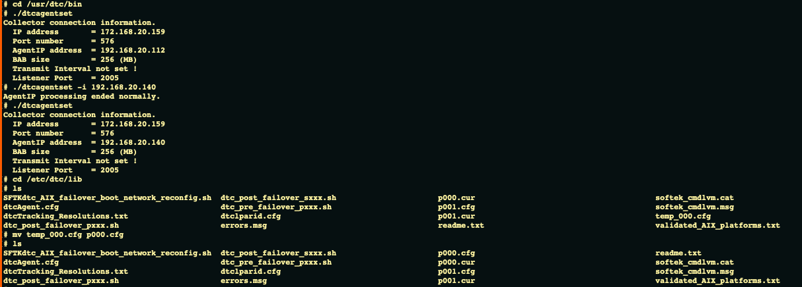

Step25:

Issue Smart refresh

On DMC

-- connect localhost

-- Select domain (not specified)

-- Select server <DRLPAR IP address>

-- select group <group number>

-- command group launchrefresh

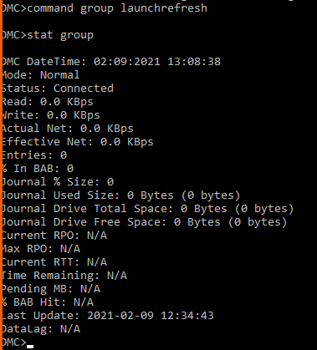

Step26:

Shutdown DRLPAR

https://192.168.1.99/rest/api/uom/LogicalPartition/5177A63E-C8E2-4DBF-8EC5-1C5412CBA126/do/PowerOff

Step27:

Get shutdown job status

https://192.168.1.99/rest/api/uom/jobs/1604760887309

Step28:

Detach disks from DRLPAR

trgtOS

trgtTDMF

https://192.168.1.99:443/rest/api/uom/VirtualIOServer/05EBC80B-E35B-49C5-9896-B09C3D9A3457/

Step29:

Attach disks to DRSALPAR

trgtOS

trgtTDMF

https://192.168.1.99:443/rest/api/uom/VirtualIOServer/05EBC80B-E35B-49C5-9896-B09C3D9A3457/

Step30:

Create/Deploy PR AIX LPAR/LPAR

https://192.168.1.99/rest/api/uom/ManagedSystem/4ca040d9-08b8-3f9f-8da3-72822d9a0922/LogicalPartition

Step31:

Create a Network adapter on PR LPAR

https://192.168.1.99/rest/api/uom/LogicalPartition/{PR LPAR UUID}/ClientNetworkAdapter

Step32:

Detach disks from PRSALPAR

tdmflpar1_lv

Data_Tdmf_2

https://192.168.1.99:443/rest/api/uom/VirtualIOServer/05EBC80B-E35B-49C5-9896-B09C3D9A3457/

Step33:

Attach to PRLPAR

tdmflpar1_lv

Data_Tdmf_2

https://192.168.1.99:443/rest/api/uom/VirtualIOServer/05EBC80B-E35B-49C5-9896-B09C3D9A3457/

Step34:

Start PRLPAR (The IP address has to be set up manually)

https://192.168.1.99/rest/api/uom/LogicalPartition/5207966C-04D5-4D93-B0CE-4FA47EB05FC5/do/PowerOn

Step35:

Get Start PR LPAR job status

https://192.168.1.99/rest/api/uom/jobs/1604760887309

Step36:

Get PRLPAR details

https://192.168.1.99/rest/api/uom/ManagedSystem/4ca040d9-08b8-3f9f-8da3-72822d9a0922/LogicalPartition/5177A63E-C8E2-4DBF-8EC5-1C5412CBA126

Step37:

Update KVs

Step38:

Listing Action

Manual steps to bootup into the OS of the recovered LPAR and perform IP change/assignment at OS level.

**Note:** Manual Task for IP assignment, in case of different IP

The IP address assigned to the LPAR is a manual job that needs to be done after login into the LPAR OS and cannot be automated from HMC APIs. VTMENU from HMC CLI needs to be used to set the boot order as LPAR boots into firmware/SMS mode. After the OS boots, log in to the OS from VTMENU console and set the relevant IP address.

In case of using the same IP address the LPAR, login to VTMENU and setting boot order is required to boot up the recovered LPAR.

#### Fallback Resync :

**Prerequisites:**

* IBM Power HMC service and credentials,
* Power Server name,
* PR LPAR/LPAR details,
* DR Staging LPAR/LPAR,
* Replicated Disk details (disk name, size, unique device ID),
* DMC Management Service,
* Replication OS level Disk detail (disk name, size, unique device ID),
* IBM Power Server Network details (Virtual Switch UUID, ID, VLAN ID),
* Processor type and numbers (Min, Max, and desired VP and PU’s),
* Memory details (Min, Max, and desired memory size in MB)

Assuming Storage Setup are same for Primary and Target Site.

Step1:

Stop Agent based RBR on the PRLPAR

./killdtcmaster

./killagent

Step2:

Start Agent based RBR on the PRLPAR

./launchdtcmaster

./launchagent

Step3:

Create virtual disk for Pstore on PR VIOS

Pstore_FOLPAR_disk (size 1GB)

https://192.168.1.99:443/rest/api/uom/VirtualIOServer/05EBC80B-E35B-49C5-9896-B09C3D9A3457/VolumeGroup/c9081d9f-d927-3019-bae0-686aa0d952f3

Step4:

Attach Pstore disk to PR LPAR

Pstore_FOLPAR_disk (size 1GB)

https://192.168.1.99:443/rest/api/uom/VirtualIOServer/05EBC80B-E35B-49C5-9896-B09C3D9A3457/

Step5:

Create VG and logical volume from the Pstore disk on PR LPAR



Step6:

Get any existing Mobility group info from PRLPAR (to find old MGs from initial replication)

on DMC

-- Connect localhost

-- Select domain (not specified)

-- Select server <PRLPAR IP>

-- list group

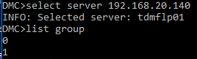

Step7:

Identify the group and Delete Mobility group for PRLPAR (Delete the old MG from initial replication)

On DMC

-- connect localhost

-- Select domain (not specified)

-- Select server <PRLPAR IP>

-- select group <mg number DRLPAR to PRSALPAR group>

-- delete group

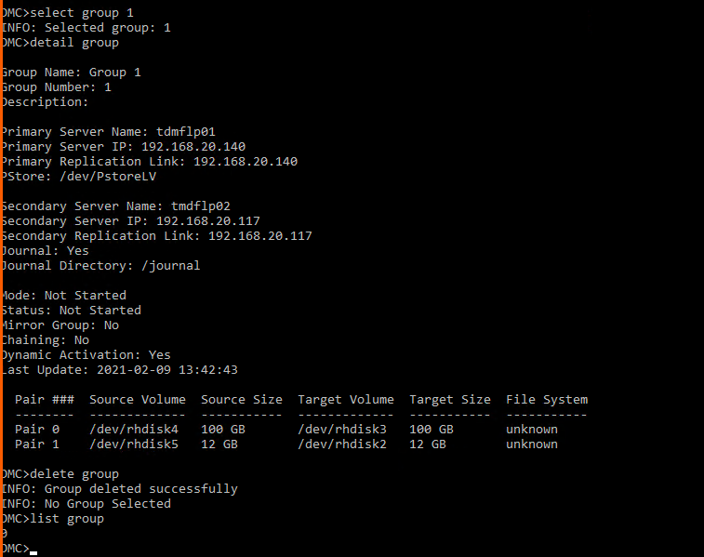

Step8:

Get disk unique identifier and path (/dev/rhdisk0 etc) info from PR and DR LPAR/SAVMs & store in RO - for identifying the disk irrespective of changes to the path or other info during attaching and detach operations etc.

The option is to use disk Unique device ID and match the value with the lspv -u command output from OS and find the unique device ID. Populate the relevant hdisk value as outkey. This will be performed for both PR and DR disks and will be used by refresh devices DMC RAL to create replication pair info.

Step9:

Create mobility group with Pstore and journal

On DMC

-- connect localhost

-- Select domain (not specified)

-- Select server <PRLPAR IP address>

-- add group -t <DRSA LPAR>

-- set group pstoredirectory </dev/lvname>

-- set group journal yes

-- set group journaldirectory </journal>

-- save group



Step10:

List devise on PR LPAR

On DMC

-- connect localhost

-- Select domain (not specified)

-- Select server <PRLPAR IP address>

-- list device -v



Step11:

List Device on DR SALPAR

On DMC

-- connect localhost

-- Select domain (not specified)

-- Select server <DRSALPAR IP address>

-- list device -v



Step12:

Add replication Pair(s)

On DMC

-- Select domain

-- Select server <PRLPAR IP address>

-- select group <group number>

DMC>add pair /dev/rhdisk0 /dev/rhdisk3

INFO: Pair Created

INFO: Selected pair: /dev/rhdisk0 => /dev/rhdisk3 (modified)

DMC>add pair /dev/rhdisk1 /dev/rhdisk1

INFO: Pair Created

INFO: Selected pair: /dev/rhdisk1 => /dev/rhdisk1 (modified)

DMC>save group

INFO: Group saved successfully





Step13:

Start Mobility group

On DMC

-- connect localhost

-- Select domain (not specified)

-- Select server <PRLPAR IP address>

-- select group <group number>

-- command group start



Step14:

Verify group to be Passthru and accumulate

On DMC

-- connect localhost

-- Select domain (not specified)

-- Select server <PRLPAR IP address>

-- select group <group number>

-- detail group



Step15:

Launch full refresh

On DMC

-- connect localhost

-- Select domain (not specified)

-- Select server <PRLPAR IP address>

-- select group <group number>

-- command group launchrefresh -f

Step16:

Check replication status to become Normal

-- Select domain

-- Select server <PRLPAR IP>

-- select group <mg number>

-- stat group



Step17:

Get any existing Mobility group info from DRLPAR (to find old MGs from previous FO tasks for the LPAR)

on DMC

-- Connect localhost

-- Select domain (not specified)

-- Select server <DRLPAR IP>

-- list group



Step18:

Delete Mobility group for DRLPAR (Delete the old MGs from previous FO tasks for the LPAR)

On DMC

-- connect localhost

-- Select domain (not specified)

-- Select server <DRLPAR IP>

-- select group <mg number DRLPAR to PRSALPAR group>

-- delete group



Step19:

Delete DR LPAR

https://192.168.1.99:443/rest/api/uom/LogicalPartition/5177A63E-C8E2-4DBF-8EC5-1C5412CBA126

Step20:

Delete FO LPAR’s Pstore disk

Pstore_FOLPAR_disk

https://192.168.1.99:443/rest/api/uom/VirtualIOServer/05EBC80B-E35B-49C5-9896-B09C3D9A3457/VolumeGroup/c9081d9f-d927-3019-bae0-686aa0d952f3

Step21:

Update KVs

Step22:

Listing Action

Manual steps to bootup into the OS of the recovered LPAR and perform IP change/assignment at OS level.

**Note:** Fallback Resync is available only for manual import in this solution and needs to be manually imported in the existing Fallback placeholder workflow. The fallback resync workflow will be available for import from the path /opt/panaces/workflows/IBR/AixWithTDMF in the IBM RO.

Validation Rules

Not available for the current release

### Recovery Automation Library

Explanation about RALs including inputs, output, and the command with examples.

Listed down are the RALs required with sample command and output

*RAL info has to be updated here*

Cloud LPAR

* + 1. Create LPAR:

curl -X PUT -k -H 'X-API-Session: 0B2tbsDwN6IjE7MauUAQ9YwP7M1pIVN8wwiKmNm2-CoaJMuTHcvCfISSbTBA2axjHVf2ABvw-oHMU2KB3DqufHAMDO3EKRwPbMoZDQmauqGoKEcaNfL7MgDLqwyAok5F4oRCVdOG0BBsvdbzOQzoFgOC0ozFpiDy6DuZrOI05dvb5ToUZ93-iadHZWTZ9Y6y5yf2vrZqGSjTjvsnr-lU0oyPiNsOpoPiTTJr62PFIJ0=' -H 'Content-Type: application/vnd.ibm.powervm.uom+xml' -H 'type: LogicalPartition' -H 'Accept: application/atom+xml;' -i 'https://192.168.1.99/rest/api/uom/ManagedSystem/4ca040d9-08b8-3f9f-8da3-72822d9a0922/LogicalPartition/' --data '<LogicalPartition:LogicalPartition xmlns:LogicalPartition="http://www.ibm.com/xmlns/systems/power/firmware/uom/mc/2012_10/" xmlns="http://www.ibm.com/xmlns/systems/power/firmware/uom/mc/2012_10/" xmlns:ns2="http://www.w3.org/XML/1998/namespace/k2" schemaVersion="V1_7_0">

<PartitionID kb="COD" kxe="false">29</PartitionID>

<PartitionMemoryConfiguration kb="CUD" kxe="false" schemaVersion="V1_7_0">

<Metadata>

<Atom/>

</Metadata>

<DesiredMemory kb="CUD" kxe="false">512</DesiredMemory>

<MaximumMemory kb="CUD" kxe="false">1024</MaximumMemory>

<MinimumMemory kb="CUD" kxe="false">512</MinimumMemory>

</PartitionMemoryConfiguration>

<PartitionName kxe="false" kb="CUR">Raj_LPAR_Test</PartitionName>

<PartitionProcessorConfiguration kxe="false" kb="CUD" schemaVersion="V1_7_0">

<Metadata>

<Atom/>

</Metadata>

<HasDedicatedProcessors kb="CUD" kxe="false">false</HasDedicatedProcessors>

<SharedProcessorConfiguration kb="CUD" kxe="false" schemaVersion="V1_7_0">

<Metadata>

<Atom/>

</Metadata>

<DesiredProcessingUnits kb="CUD" kxe="false">0.1</DesiredProcessingUnits>

<DesiredVirtualProcessors kxe="false" kb="CUD">1</DesiredVirtualProcessors>

<MaximumProcessingUnits kxe="false" kb="CUD">1</MaximumProcessingUnits>

<MaximumVirtualProcessors kb="CUD" kxe="false">2</MaximumVirtualProcessors>

<MinimumProcessingUnits kb="CUD" kxe="false">0.1</MinimumProcessingUnits>

<MinimumVirtualProcessors kb="CUD" kxe="false">1</MinimumVirtualProcessors>

<SharedProcessorPoolID kb="CUD" kxe="false">0</SharedProcessorPoolID>

<UncappedWeight kb="CUD" kxe="false">128</UncappedWeight>

</SharedProcessorConfiguration>

<SharingMode kb="CUD" kxe="false">uncapped</SharingMode>

</PartitionProcessorConfiguration>

<PartitionType kxe="false" kb="COD">AIX/Linux</PartitionType>

</LogicalPartition:LogicalPartition>

'

Response:

<entry xmlns="http://www.w3.org/2005/Atom" xmlns:ns2="http://a9.com/-/spec/opensearch/1.1/" xmlns:ns3="http://www.w3.org/1999/xhtml">

<id>0C79A6D5-8D67-4726-B613-4D28D91302DD</id>

<title>LogicalPartition</title>

<published>2020-12-28T14:42:56.689+05:30</published>

<link rel="SELF" href="https://192.168.1.99:443/rest/api/uom/LogicalPartition/0C79A6D5-8D67-4726-B613-4D28D91302DD"/>

<link rel="SELF" href="https://192.168.1.99:443/rest/api/uom/ManagedSystem/4ca040d9-08b8-3f9f-8da3-72822d9a0922/LogicalPartition/0C79A6D5-8D67-4726-B613-4D28D91302DD"/>

<link rel="MANAGEMENT_CONSOLE" href="https://192.168.1.99:443/rest/api/uom/ManagementConsole/53069e73-004d-374b-9d93-e6f268db57ef"/>

<author>

<name>IBM Power Systems Management Console</name>

</author>

<etag:etag xmlns:etag="http://www.ibm.com/xmlns/systems/power/firmware/uom/mc/2012_10/" xmlns="http://www.ibm.com/xmlns/systems/power/firmware/uom/mc/2012_10/">-331784121</etag:etag>

<content type="application/vnd.ibm.powervm.uom+xml; type=LogicalPartition">

<LogicalPartition:LogicalPartition xmlns:LogicalPartition="http://www.ibm.com/xmlns/systems/power/firmware/uom/mc/2012_10/" xmlns="http://www.ibm.com/xmlns/systems/power/firmware/uom/mc/2012_10/" xmlns:ns2="http://www.w3.org/XML/1998/namespace/k2" schemaVersion="V1_7_0">

<Metadata>

<Atom>

<AtomID>0C79A6D5-8D67-4726-B613-4D28D91302DD</AtomID>

<AtomCreated>1609146776687</AtomCreated>

</Atom>

</Metadata>

<AllowPerformanceDataCollection kb="CUD" kxe="false">false</AllowPerformanceDataCollection>

<AssociatedPartitionProfile kb="CUD" kxe="false" href="https://192.168.1.99:443/rest/api/uom/LogicalPartition/0C79A6D5-8D67-4726-B613-4D28D91302DD/LogicalPartitionProfile/96cb8fa0-36e3-3ea7-9b5b-739a6f41cca8" rel="related"/>

<AvailabilityPriority kb="UOD" kxe="false">127</AvailabilityPriority>

<CurrentProcessorCompatibilityMode kxe="false" kb="ROO">POWER8</CurrentProcessorCompatibilityMode>

<CurrentProfileSync kb="CUD" kxe="false">Disabled</CurrentProfileSync>

<IsBootable ksv="V1_3_0" kb="ROO" kxe="false">true</IsBootable>

<IsConnectionMonitoringEnabled kb="UOD" kxe="false">true</IsConnectionMonitoringEnabled>

<IsOperationInProgress kb="ROR" kxe="false">false</IsOperationInProgress>

<IsRedundantErrorPathReportingEnabled kb="UOD" kxe="false">false</IsRedundantErrorPathReportingEnabled>

<IsTimeReferencePartition kxe="false" kb="UOD">false</IsTimeReferencePartition>

<IsVirtualServiceAttentionLEDOn kxe="false" kb="ROR">false</IsVirtualServiceAttentionLEDOn>

<IsVirtualTrustedPlatformModuleEnabled kxe="false" kb="UOD">false</IsVirtualTrustedPlatformModuleEnabled>

<KeylockPosition kxe="false" kb="CUD">normal</KeylockPosition>

<LogicalSerialNumber kb="ROR" kxe="false">6871D5XT</LogicalSerialNumber>

<OperatingSystemVersion kxe="false" kb="ROR">Unknown</OperatingSystemVersion>

<PartitionCapabilities kxe="false" kb="ROR" schemaVersion="V1_7_0">

<Metadata>

<Atom/>

</Metadata>

<DynamicLogicalPartitionIOCapable kxe="false" kb="ROR">false</DynamicLogicalPartitionIOCapable>

<DynamicLogicalPartitionMemoryCapable kxe="false" kb="ROR">false</DynamicLogicalPartitionMemoryCapable>

<DynamicLogicalPartitionProcessorCapable kxe="false" kb="ROR">false</DynamicLogicalPartitionProcessorCapable>

<InternalAndExternalIntrusionDetectionCapable kb="CUD" kxe="false">false</InternalAndExternalIntrusionDetectionCapable>

<ResourceMonitoringControlOperatingSystemShutdownCapable kb="CUD" kxe="false">false</ResourceMonitoringControlOperatingSystemShutdownCapable>

</PartitionCapabilities>

<PartitionID kb="COD" kxe="false">29</PartitionID>

<PartitionIOConfiguration kxe="false" kb="CUD" schemaVersion="V1_7_0">

<Metadata>

<Atom/>

</Metadata>

<MaximumVirtualIOSlots kb="CUD" kxe="false">6</MaximumVirtualIOSlots>

<ProfileIOSlots kb="CUD" kxe="false" schemaVersion="V1_7_0">

<Metadata>

<Atom/>

</Metadata>

</ProfileIOSlots>

<CurrentMaximumVirtualIOSlots kb="ROR" kxe="false">6</CurrentMaximumVirtualIOSlots>

</PartitionIOConfiguration>

<PartitionMemoryConfiguration kb="CUD" kxe="false" schemaVersion="V1_7_0">

<Metadata>

<Atom/>

</Metadata>

<ActiveMemoryExpansionEnabled kxe="false" kb="CUD">false</ActiveMemoryExpansionEnabled>

<ActiveMemorySharingEnabled kxe="false" kb="CUD">false</ActiveMemorySharingEnabled>

<DesiredHugePageCount kb="CUD" kxe="false">0</DesiredHugePageCount>

<DesiredMemory kb="CUD" kxe="false">512</DesiredMemory>

<ExpansionFactor kxe="false" kb="CUD">0.0</ExpansionFactor>

<HardwarePageTableRatio kb="CUD" kxe="false">7</HardwarePageTableRatio>

<MaximumHugePageCount kxe="false" kb="CUD">0</MaximumHugePageCount>

<MaximumMemory kb="CUD" kxe="false">1024</MaximumMemory>

<MinimumHugePageCount kxe="false" kb="CUD">0</MinimumHugePageCount>

<MinimumMemory kb="CUD" kxe="false">512</MinimumMemory>

<CurrentExpansionFactor kb="ROR" kxe="false">0.0</CurrentExpansionFactor>

<CurrentHardwarePageTableRatio kb="ROR" kxe="false">7</CurrentHardwarePageTableRatio>

<CurrentHugePageCount kxe="false" kb="ROR">0</CurrentHugePageCount>

<CurrentMaximumHugePageCount kxe="false" kb="ROR">0</CurrentMaximumHugePageCount>

<CurrentMaximumMemory kxe="false" kb="ROR">1024</CurrentMaximumMemory>

<CurrentMemory kxe="false" kb="ROR">512</CurrentMemory>

<CurrentMinimumHugePageCount kxe="false" kb="ROR">0</CurrentMinimumHugePageCount>

<CurrentMinimumMemory kb="ROR" kxe="false">512</CurrentMinimumMemory>

<MemoryExpansionHardwareAccessEnabled kxe="false" kb="ROR">false</MemoryExpansionHardwareAccessEnabled>

<MemoryEncryptionHardwareAccessEnabled kxe="false" kb="ROR">true</MemoryEncryptionHardwareAccessEnabled>

<MemoryExpansionEnabled kxe="false" kb="ROR">false</MemoryExpansionEnabled>

<RedundantErrorPathReportingEnabled kb="ROR" kxe="false">false</RedundantErrorPathReportingEnabled>

<RuntimeHugePageCount kxe="false" kb="ROR">0</RuntimeHugePageCount>

<RuntimeMemory kb="ROR" kxe="false">256</RuntimeMemory>

<RuntimeMinimumMemory kxe="false" kb="ROR">512</RuntimeMinimumMemory>

<SharedMemoryEnabled kb="CUD" kxe="false">false</SharedMemoryEnabled>

<PhysicalPageTableRatio ksv="V1_6_0" kb="CUD" kxe="false">6</PhysicalPageTableRatio>

</PartitionMemoryConfiguration>

<PartitionName kxe="false" kb="CUR">Raj_LPAR_Test</PartitionName>

<PartitionProcessorConfiguration kxe="false" kb="CUD" schemaVersion="V1_7_0">

<Metadata>

<Atom/>

</Metadata>

<HasDedicatedProcessors kb="CUD" kxe="false">false</HasDedicatedProcessors>

<SharedProcessorConfiguration kb="CUD" kxe="false" schemaVersion="V1_7_0">

<Metadata>

<Atom/>

</Metadata>

<DesiredProcessingUnits kb="CUD" kxe="false">0.1</DesiredProcessingUnits>

<DesiredVirtualProcessors kxe="false" kb="CUD">1</DesiredVirtualProcessors>

<MaximumProcessingUnits kxe="false" kb="CUD">1</MaximumProcessingUnits>

<MaximumVirtualProcessors kb="CUD" kxe="false">2</MaximumVirtualProcessors>

<MinimumProcessingUnits kb="CUD" kxe="false">0.1</MinimumProcessingUnits>

<MinimumVirtualProcessors kb="CUD" kxe="false">1</MinimumVirtualProcessors>

<SharedProcessorPoolID kb="CUD" kxe="false">0</SharedProcessorPoolID>

<UncappedWeight kb="CUD" kxe="false">128</UncappedWeight>

</SharedProcessorConfiguration>

<SharingMode kb="CUD" kxe="false">uncapped</SharingMode>

<CurrentHasDedicatedProcessors kxe="false" kb="ROR">false</CurrentHasDedicatedProcessors>

<CurrentSharingMode kxe="false" kb="ROR">uncapped</CurrentSharingMode>

<RuntimeHasDedicatedProcessors kb="ROR" kxe="false">false</RuntimeHasDedicatedProcessors>

<CurrentSharedProcessorConfiguration kxe="false" kb="ROR" schemaVersion="V1_7_0">

<Metadata>

<Atom/>

</Metadata>

<AllocatedVirtualProcessors kxe="false" kb="ROR">1</AllocatedVirtualProcessors>

<CurrentMaximumProcessingUnits kb="ROR" kxe="false">1</CurrentMaximumProcessingUnits>

<CurrentMinimumProcessingUnits kb="ROR" kxe="false">0.1</CurrentMinimumProcessingUnits>

<CurrentProcessingUnits kxe="false" kb="ROR">0.1</CurrentProcessingUnits>

<CurrentSharedProcessorPoolID kb="ROR" kxe="false">0</CurrentSharedProcessorPoolID>

<CurrentUncappedWeight kxe="false" kb="ROR">128</CurrentUncappedWeight>

<CurrentMinimumVirtualProcessors kb="ROR" kxe="false">1</CurrentMinimumVirtualProcessors>

<CurrentMaximumVirtualProcessors kb="ROR" kxe="false">2</CurrentMaximumVirtualProcessors>

<RuntimeProcessingUnits kxe="false" kb="ROR">0</RuntimeProcessingUnits>

<RuntimeUncappedWeight kxe="false" kb="ROR">0</RuntimeUncappedWeight>

</CurrentSharedProcessorConfiguration>

</PartitionProcessorConfiguration>

<PartitionProfiles kxe="false" kb="CUD">

<link href="https://192.168.1.99:443/rest/api/uom/LogicalPartition/0C79A6D5-8D67-4726-B613-4D28D91302DD/LogicalPartitionProfile/96cb8fa0-36e3-3ea7-9b5b-739a6f41cca8" rel="related"/>

</PartitionProfiles>

<PartitionState kb="ROO" kxe="false">not activated</PartitionState>

<PartitionType kxe="false" kb="COD">AIX/Linux</PartitionType>

<PartitionUUID kb="ROO" kxe="false">0C79A6D5-8D67-4726-B613-4D28D91302DD</PartitionUUID>

<PendingProcessorCompatibilityMode kb="CUD" kxe="false">default</PendingProcessorCompatibilityMode>

<ProcessorPool kxe="false" kb="CUD" href="https://192.168.1.99:443/rest/api/uom/ManagedSystem/4ca040d9-08b8-3f9f-8da3-72822d9a0922/SharedProcessorPool/d74e61d1-7963-352a-b53b-ffb9e8c11f0c" rel="related"/>

<ProgressPartitionDataRemaining kb="ROR" kxe="false">0</ProgressPartitionDataRemaining>

<ProgressPartitionDataTotal kxe="false" kb="ROR">0</ProgressPartitionDataTotal>

<ProgressState kxe="false" kb="ROR"/>

<ResourceMonitoringControlState kb="ROR" kxe="false">inactive</ResourceMonitoringControlState>

<AssociatedManagedSystem kxe="false" kb="CUD" href="https://192.168.1.99:443/rest/api/uom/ManagedSystem/4ca040d9-08b8-3f9f-8da3-72822d9a0922" rel="related"/>

<HostEthernetAdapterLogicalPorts kxe="false" kb="CUD" schemaVersion="V1_7_0">

<Metadata>

<Atom/>

</Metadata>

</HostEthernetAdapterLogicalPorts>

<IsServicePartition kxe="false" kb="CUD">false</IsServicePartition>

<PowerVMManagementCapable ksv="V1_5_0" kxe="false" kb="ROR">false</PowerVMManagementCapable>

<ReferenceCode kb="ROO" kxe="true">00000000</ReferenceCode>

<AssignAllResources ksv="V1_6_0" kb="COD" kxe="false">false</AssignAllResources>

<HardwareAcceleratorQoS ksv="V1_7_0" kxe="false" kb="CUD" schemaVersion="V1_7_0">

<Metadata>

<Atom/>

</Metadata>

</HardwareAcceleratorQoS>

<LastActivatedProfile ksv="V1_7_0" kxe="false" kb="ROO">default_profile</LastActivatedProfile>

<HasPhysicalIO ksv="V1_7_0" kxe="false" kb="ROO">false</HasPhysicalIO>

<PowerOnWithHypervisor ksv="V1_2_0" kxe="false" kb="CUD">false</PowerOnWithHypervisor>

<RemoteRestartCapable kxe="false" kb="CUA">false</RemoteRestartCapable>

<SimplifiedRemoteRestartCapable ksv="V1_2_0" kxe="false" kb="CUD">false</SimplifiedRemoteRestartCapable>

<HasDedicatedProcessorsForMigration kb="ROR" kxe="false">false</HasDedicatedProcessorsForMigration>

<SuspendCapable kxe="false" kb="CUD">false</SuspendCapable>

<MigrationDisable ksv="V1_3_0" kb="CUD" kxe="false">false</MigrationDisable>

<MigrationState kb="ROR" kxe="false">Not_Migrating</MigrationState>

<RemoteRestartState kxe="false" kb="ROR">Invalid</RemoteRestartState>

<BootListInformation ksv="V1_5_0" kxe="false" kb="UOD" schemaVersion="V1_7_0">

<Metadata>

<Atom/>

</Metadata>

<PendingBootString group="Advanced" ksv="V1_5_0" kxe="false" kb="UOO"/>

<BootDeviceList group="Advanced" ksv="V1_5_0" kxe="false" kb="ROO"/>

<ShadowBootDeviceList group="Advanced" ksv="V1_5_0" kb="ROO" kxe="false"/>

<LastBootedDeviceString group="Advanced" ksv="V1_5_0" kb="ROO" kxe="false"/>

</BootListInformation>

</LogicalPartition:LogicalPartition>

</content>

</entry>

* + 1. Addition of Virtual Network to LPAR

curl -X PUT -k -H 'X-API-Session: 0B2tbsDwN6IjE7MauUAQ9YwP7M1pIVN8wwiKmNm2-CoaJMuTHcvCfISSbTBA2axjHVf2ABvw-oHMU2KB3DqufHAMDO3EKRwPbMoZDQmauqGoKEcaNfL7MgDLqwyAok5F4oRCVdOG0BBsvdbzOQzoFgOC0ozFpiDy6DuZrOI05dvb5ToUZ93-iadHZWTZ9Y6y5yf2vrZqGSjTjvsnr-lU0oyPiNsOpoPiTTJr62PFIJ0=' -H 'Content-Type: application/vnd.ibm.powervm.uom+xml' -H 'type: ClientNetworkAdapter' -H 'Accept: application/atom+xml;' -i 'https://192.168.1.99/rest/api/uom/LogicalPartition/49300E3F-36C6-4EA1-ACC1-E97839FEB7E1/ClientNetworkAdapter/' --data '<ClientNetworkAdapter:ClientNetworkAdapter xmlns:ClientNetworkAdapter="http://www.ibm.com/xmlns/systems/power/firmware/uom/mc/2012_10/" xmlns="http://www.ibm.com/xmlns/systems/power/firmware/uom/mc/2012_10/" xmlns:ns2="http://www.w3.org/XML/1998/namespace/k2" schemaVersion="V1_7_0">

<PortVLANID kb="CUR" kxe="false">30</PortVLANID>

<AssociatedVirtualSwitch kb="CUD" kxe="false">

<link href="https://192.168.1.99:443/rest/api/uom/ManagedSystem/4ca040d9-08b8-3f9f-8da3-72822d9a0922/VirtualSwitch/d43a37d2-9698-3b36-ae04-245df68d2689" rel="related"/>

</AssociatedVirtualSwitch>

</ClientNetworkAdapter:ClientNetworkAdapter>'

Response:

<entry xmlns="http://www.w3.org/2005/Atom" xmlns:ns2="http://a9.com/-/spec/opensearch/1.1/" xmlns:ns3="http://www.w3.org/1999/xhtml">

<id>52b1da8f-466c-3f27-a692-a77fe2298ec0</id>

<title>ClientNetworkAdapter</title>

<published>2020-12-28T15:08:58.214+05:30</published>

<link rel="SELF" href="https://192.168.1.99:443/rest/api/uom/LogicalPartition/0C79A6D5-8D67-4726-B613-4D28D91302DD/ClientNetworkAdapter/52b1da8f-466c-3f27-a692-a77fe2298ec0"/>

<link rel="MANAGEMENT_CONSOLE" href="https://192.168.1.99:443/rest/api/uom/ManagementConsole/53069e73-004d-374b-9d93-e6f268db57ef"/>

<author>

<name>IBM Power Systems Management Console</name>

</author>

<etag:etag xmlns:etag="http://www.ibm.com/xmlns/systems/power/firmware/uom/mc/2012_10/" xmlns="http://www.ibm.com/xmlns/systems/power/firmware/uom/mc/2012_10/">1301764023</etag:etag>

<content type="application/vnd.ibm.powervm.uom+xml; type=ClientNetworkAdapter">

<ClientNetworkAdapter:ClientNetworkAdapter xmlns:ClientNetworkAdapter="http://www.ibm.com/xmlns/systems/power/firmware/uom/mc/2012_10/" xmlns="http://www.ibm.com/xmlns/systems/power/firmware/uom/mc/2012_10/" xmlns:ns2="http://www.w3.org/XML/1998/namespace/k2" schemaVersion="V1_7_0">

<Metadata>

<Atom>

<AtomID>52b1da8f-466c-3f27-a692-a77fe2298ec0</AtomID>

<AtomCreated>1609148338213</AtomCreated>

</Atom>

</Metadata>

<DynamicReconfigurationConnectorName kxe="false" kb="CUD">U8286.42A.6871D5X-V29-C2</DynamicReconfigurationConnectorName>

<LocationCode kxe="false" kb="ROR">U8286.42A.6871D5X-V29-C2</LocationCode>

<LocalPartitionID kb="CUR" kxe="false">29</LocalPartitionID>

<RequiredAdapter kb="CUD" kxe="false">false</RequiredAdapter>

<VariedOn kb="CUD" kxe="true">false</VariedOn>

<VirtualSlotNumber kb="COD" kxe="false">2</VirtualSlotNumber>

<AllowedOperatingSystemMACAddresses kb="CUD" kxe="false">ALL</AllowedOperatingSystemMACAddresses>

<MACAddress kxe="false" kb="CUR">56EF52A78102</MACAddress>

<PortVLANID kb="CUR" kxe="false">30</PortVLANID>

<QualityOfServicePriorityEnabled kb="CUD" kxe="false">false</QualityOfServicePriorityEnabled>

<TaggedVLANSupported kxe="false" kb="CUA">false</TaggedVLANSupported>

<AssociatedVirtualSwitch kb="CUD" kxe="false">

<link href="https://192.168.1.99:443/rest/api/uom/ManagedSystem/4ca040d9-08b8-3f9f-8da3-72822d9a0922/VirtualSwitch/d43a37d2-9698-3b36-ae04-245df68d2689" rel="related"/>

</AssociatedVirtualSwitch>

<VirtualSwitchID kb="ROR" kxe="false">0</VirtualSwitchID>

<VirtualNetworks kxe="false" kb="CUR">

<link href="https://192.168.1.99:443/rest/api/uom/ManagedSystem/4ca040d9-08b8-3f9f-8da3-72822d9a0922/VirtualNetwork/6de1cd97-d473-30a3-96be-14dbf7a051fe" rel="related"/>

</VirtualNetworks>

</ClientNetworkAdapter:ClientNetworkAdapter>

</content>

</entry>

* + 1. LPAR activate/PowerON

curl -X PUT -k -H 'X-API-Session: 0B2tbsDwN6IjE7MauUAQ9YwP7M1pIVN8wwiKmNm2-CoKbg7wT7Ql4Pd9gVRvG82oREHDCQ3Q57m7B5SYXx4_tlm6vU_skkmjDiBjpHL3GQnCuVSaAFkCspin3xByJzSMVDkCCpfyYhksmScTxYvnRGPsaGI_OMOjCFxNkUeM8MR8gj2kwnO8fAi-MjiMxye3YDGSzWuvIKDyXaC208krSh2SEL5S0GgfNRoHr2bQe5g=' -H 'Content-Type: application/vnd.ibm.powervm.web+xml' -H 'Type: JobRequest' -i 'https://192.168.1.99/rest/api/uom/LogicalPartition/49300E3F-36C6-4EA1-ACC1-E97839FEB7E1/do/PowerOn' --data '<JobRequest:JobRequest

xmlns:JobRequest="http://www.ibm.com/xmlns/systems/power/firmware/web/mc/2012_10/"

xmlns="http://www.ibm.com/xmlns/systems/power/firmware/web/mc/2012_10/"

xmlns:ns2="http://www.w3.org/XML/1998/namespace/k2" schemaVersion="V1_7_0">

<Metadata>

<Atom/>

</Metadata>

<RequestedOperation kb="CUR" kxe="false" schemaVersion="V1_7_0">

<Metadata>

<Atom/>

</Metadata>

<OperationName kb="ROR" kxe="false">PowerOn</OperationName>

<GroupName kb="ROR" kxe="false">LogicalPartition</GroupName>

</RequestedOperation>

<JobParameters kb="CUR" kxe="false" schemaVersion="V1_7_0">

<Metadata>

<Atom/>

</Metadata>

<JobParameter schemaVersion="V1_7_0">

<Metadata>

<Atom/>

</Metadata>

<ParameterName kxe="false" kb="ROR">force</ParameterName>

<ParameterValue kxe="false" kb="CUR">false</ParameterValue>

</JobParameter>

<JobParameter schemaVersion="V1_7_0">

<Metadata>

<Atom/>

</Metadata>

<ParameterName kxe="false" kb="ROR">LogicalPartitionProfile</ParameterName>

<ParameterValue kxe="false" kb="CUR">default_profile</ParameterValue>

</JobParameter>

<JobParameter schemaVersion="V1_7_0">

<Metadata>

<Atom/>

</Metadata>

<ParameterName kxe="false" kb="ROR">novsi</ParameterName>

<ParameterValue kxe="false" kb="CUR">true</ParameterValue>

</JobParameter>

<JobParameter schemaVersion="V1_7_0">

<Metadata>

<Atom/>

</Metadata>

<ParameterName kxe="false" kb="ROR">bootmode</ParameterName>

<ParameterValue kxe="false" kb="CUR">norm</ParameterValue>

</JobParameter>

<JobParameter schemaVersion="V1_7_0">

<Metadata>

<Atom/>

</Metadata>

<ParameterName kxe="false" kb="ROR">keylock</ParameterName>

<ParameterValue kxe="false" kb="CUR">manual</ParameterValue>

</JobParameter>

</JobParameters>

</JobRequest:JobRequest>'

Response:

<entry xmlns="http://www.w3.org/2005/Atom" xmlns:ns2="http://a9.com/-/spec/opensearch/1.1/" xmlns:ns3="http://www.w3.org/1999/xhtml">

<id>ccee2714-476f-4c6a-adbb-35778491d88c</id>

<title>JobResponse</title>

<published>2021-01-01T17:48:35.841+05:30</published>

<link rel="SELF" href="https://192.168.1.99:443/rest/api/uom/jobs/1604760887119"/>

<author>

<name>IBM Power Systems Management Console</name>

</author>

<content type="application/vnd.ibm.powervm.web+xml; type=JobResponse">

<JobResponse:JobResponse xmlns:JobResponse="http://www.ibm.com/xmlns/systems/power/firmware/web/mc/2012_10/" xmlns="http://www.ibm.com/xmlns/systems/power/firmware/web/mc/2012_10/" xmlns:ns2="http://www.w3.org/XML/1998/namespace/k2" schemaVersion="V1_7_0">

<Metadata>

<Atom/>

</Metadata>

<RequestURL kb="ROR" kxe="false" href="LogicalPartition/49300E3F-36C6-4EA1-ACC1-E97839FEB7E1/do/PowerOn" rel="via" title="The URL to which the JobRequest was submitted."/>

<TargetUuid kb="ROR" kxe="false">49300E3F-36C6-4EA1-ACC1-E97839FEB7E1</TargetUuid>

<JobID kxe="false" kb="ROR">1604760887119</JobID>

<TimeStarted kxe="false" kb="ROR">0</TimeStarted>

<TimeCompleted kxe="false" kb="ROR">0</TimeCompleted>

<Status kb="ROR" kxe="false">NOT_STARTED</Status>

<JobRequestInstance kb="ROR" kxe="false" schemaVersion="V1_7_0">

<Metadata>

<Atom/>

</Metadata>

<RequestedOperation kxe="false" kb="CUR" schemaVersion="V1_7_0">

<Metadata>

<Atom/>

</Metadata>

<OperationName kxe="false" kb="ROR">PowerOn</OperationName>

<GroupName kb="ROR" kxe="false">LogicalPartition</GroupName>

</RequestedOperation>

<JobParameters kb="CUR" kxe="false" schemaVersion="V1_7_0">

<Metadata>

<Atom/>

</Metadata>

<JobParameter schemaVersion="V1_7_0">

<Metadata>

<Atom/>

</Metadata>

<ParameterName kxe="false" kb="ROR">force</ParameterName>

<ParameterValue kb="CUR" kxe="false">false</ParameterValue>

</JobParameter>

<JobParameter schemaVersion="V1_7_0">

<Metadata>

<Atom/>

</Metadata>

<ParameterName kxe="false" kb="ROR">LogicalPartitionProfile</ParameterName>

<ParameterValue kb="CUR" kxe="false">default_profile</ParameterValue>

</JobParameter>

<JobParameter schemaVersion="V1_7_0">

<Metadata>

<Atom/>

</Metadata>

<ParameterName kxe="false" kb="ROR">novsi</ParameterName>

<ParameterValue kb="CUR" kxe="false">true</ParameterValue>

</JobParameter>

<JobParameter schemaVersion="V1_7_0">

<Metadata>

<Atom/>

</Metadata>

<ParameterName kxe="false" kb="ROR">bootmode</ParameterName>

<ParameterValue kb="CUR" kxe="false">norm</ParameterValue>

</JobParameter>

<JobParameter schemaVersion="V1_7_0">

<Metadata>

<Atom/>

</Metadata>

<ParameterName kxe="false" kb="ROR">keylock</ParameterName>

<ParameterValue kb="CUR" kxe="false">manual</ParameterValue>

</JobParameter>

</JobParameters>

</JobRequestInstance>

<Progress kxe="false" kb="ROO" schemaVersion="V1_7_0">

<Metadata>

<Atom/>

</Metadata>

</Progress>

<Results kxe="false" kb="ROR" schemaVersion="V1_7_0">

<Metadata>

<Atom/>

</Metadata>

</Results>

</JobResponse:JobResponse>

</content>

</entry>

* + 1. LPAR PowerOFF

curl -X PUT -k -H 'X-API-Session: 0B2tbsDwN6IjE7MauUAQ9YwP7M1pIVN8wwiKmNm2-CoKbg7wT7Ql4Pd9gVRvG82oREHDCQ3Q57m7B5SYXx4_tlm6vU_skkmjDiBjpHL3GQnCuVSaAFkCspin3xByJzSMVDkCCpfyYhksmScTxYvnRGPsaGI_OMOjCFxNkUeM8MR8gj2kwnO8fAi-MjiMxye3YDGSzWuvIKDyXaC208krSh2SEL5S0GgfNRoHr2bQe5g=' -H 'Content-Type: application/vnd.ibm.powervm.web+xml' -H 'Type: JobRequest' -i 'https://192.168.1.99/rest/api/uom/LogicalPartition/49300E3F-36C6-4EA1-ACC1-E97839FEB7E1/do/PowerOff' --data '<JobRequest

xmlns="http://www.ibm.com/xmlns/systems/power/firmware/web/mc/2012_10/"

xmlns:ns2="http://www.w3.org/XML/1998/namespace/k2" schemaVersion="V1_7_0">

<Metadata>

<Atom/>

</Metadata>

<RequestedOperation kxe="false" kb="CUR" schemaVersion="V1_7_0">

<Metadata>

<Atom/>

</Metadata>

<OperationName kxe="false" kb="ROR">PowerOff</OperationName>

<GroupName kxe="false" kb="ROR">LogicalPartition</GroupName>

<ProgressType kxe="false" kb="ROR">DISCRETE</ProgressType>

</RequestedOperation>

<JobParameters kxe="false" kb="CUR" schemaVersion="V1_7_0">

<Metadata>

<Atom/>

</Metadata>

<JobParameter schemaVersion="V1_7_0">

<Metadata>

<Atom/>

</Metadata>

<ParameterName kxe="false" kb="ROR">immediate</ParameterName>

<ParameterValue kxe="false" kb="CUR">false</ParameterValue>

</JobParameter>

<JobParameter schemaVersion="V1_7_0">

<Metadata>

<Atom/>

</Metadata>

<ParameterName kxe="false" kb="ROR">restart</ParameterName>

<ParameterValue kxe="false" kb="CUR">false</ParameterValue>

</JobParameter>

<JobParameter schemaVersion="V1_7_0">

<Metadata>

<Atom/>

</Metadata>

<ParameterName kxe="false" kb="ROR">operation</ParameterName>

<ParameterValue kxe="false" kb="CUR">shutdown</ParameterValue>

</JobParameter>

</JobParameters>

</JobRequest>'

Response:

<entry xmlns="http://www.w3.org/2005/Atom" xmlns:ns2="http://a9.com/-/spec/opensearch/1.1/" xmlns:ns3="http://www.w3.org/1999/xhtml">

<id>2aa5880d-7fb6-4202-a3eb-687369114357</id>

<title>JobResponse</title>

<published>2021-01-01T17:58:58.917+05:30</published>

<link rel="SELF" href="https://192.168.1.99:443/rest/api/uom/jobs/1604760887121"/>

<author>

<name>IBM Power Systems Management Console</name>

</author>

<content type="application/vnd.ibm.powervm.web+xml; type=JobResponse">

<JobResponse:JobResponse xmlns:JobResponse="http://www.ibm.com/xmlns/systems/power/firmware/web/mc/2012_10/" xmlns="http://www.ibm.com/xmlns/systems/power/firmware/web/mc/2012_10/" xmlns:ns2="http://www.w3.org/XML/1998/namespace/k2" schemaVersion="V1_7_0">

<Metadata>

<Atom/>

</Metadata>

<RequestURL kb="ROR" kxe="false" href="LogicalPartition/49300E3F-36C6-4EA1-ACC1-E97839FEB7E1/do/PowerOff" rel="via" title="The URL to which the JobRequest was submitted."/>

<TargetUuid kb="ROR" kxe="false">49300E3F-36C6-4EA1-ACC1-E97839FEB7E1</TargetUuid>

<JobID kxe="false" kb="ROR">1604760887121</JobID>

<TimeStarted kxe="false" kb="ROR">0</TimeStarted>

<TimeCompleted kxe="false" kb="ROR">0</TimeCompleted>

<Status kb="ROR" kxe="false">NOT_STARTED</Status>

<JobRequestInstance kb="ROR" kxe="false" schemaVersion="V1_7_0">

<Metadata>

<Atom/>

</Metadata>

<RequestedOperation kxe="false" kb="CUR" schemaVersion="V1_7_0">

<Metadata>

<Atom/>

</Metadata>

<OperationName kxe="false" kb="ROR">PowerOff</OperationName>

<GroupName kb="ROR" kxe="false">LogicalPartition</GroupName>

</RequestedOperation>

<JobParameters kb="CUR" kxe="false" schemaVersion="V1_7_0">

<Metadata>

<Atom/>

</Metadata>

<JobParameter schemaVersion="V1_7_0">

<Metadata>

<Atom/>

</Metadata>

<ParameterName kxe="false" kb="ROR">immediate</ParameterName>

<ParameterValue kb="CUR" kxe="false">false</ParameterValue>

</JobParameter>

<JobParameter schemaVersion="V1_7_0">

<Metadata>

<Atom/>

</Metadata>

<ParameterName kxe="false" kb="ROR">restart</ParameterName>

<ParameterValue kb="CUR" kxe="false">false</ParameterValue>

</JobParameter>

<JobParameter schemaVersion="V1_7_0">

<Metadata>

<Atom/>

</Metadata>

<ParameterName kxe="false" kb="ROR">operation</ParameterName>

<ParameterValue kb="CUR" kxe="false">shutdown</ParameterValue>

</JobParameter>

</JobParameters>

</JobRequestInstance>

<Progress kxe="false" kb="ROO" schemaVersion="V1_7_0">

<Metadata>

<Atom/>

</Metadata>

</Progress>

<Results kxe="false" kb="ROR" schemaVersion="V1_7_0">

<Metadata>

<Atom/>

</Metadata>

</Results>

</JobResponse:JobResponse>

</content>

</entry>

* + 1. Add VirtualSCSIClient Adapter to LPAR

curl -X PUT -k -H 'X-API-Session: 0B2tbsDwN6IjE7MauUAQ9YwP7M1pIVN8wwiKmNm2-CoKbg7wT7Ql4Pd9gVRvG82oREHDCQ3Q57m7B5SYXx4_tlm6vU_skkmjDiBjpHL3GQnCuVSaAFkCspin3xByJzSMVDkCCpfyYhksmScTxYvnRGPsaGI_OMOjCFxNkUeM8MR8gj2kwnO8fAi-MjiMxye3YDGSzWuvIKDyXaC208krSh2SEL5S0GgfNRoHr2bQe5g=' -H 'Content-Type: application/vnd.ibm.powervm.uom+xml' -H 'Type: VirtualSCSIClientAdapter' -i 'https://192.168.1.99/rest/api/uom/LogicalPartition/49300E3F-36C6-4EA1-ACC1-E97839FEB7E1/VirtualSCSIClientAdapter/' --data '<VirtualSCSIClientAdapter:VirtualSCSIClientAdapter xmlns:VirtualSCSIClientAdapter="http://www.ibm.com/xmlns/systems/power/firmware/uom/mc/2012_10/" xmlns="http://www.ibm.com/xmlns/systems/power/firmware/uom/mc/2012_10/" xmlns:ns2="http://www.w3.org/XML/1998/namespace/k2" schemaVersion="V1_7_0">

<Metadata>

<Atom/>

</Metadata>

<AdapterType kb="ROR" kxe="false">Client</AdapterType>

<DynamicReconfigurationConnectorName kxe="false" kb="CUD">U8286.42A.6871D5X-V29-C4</DynamicReconfigurationConnectorName>

<LocationCode kxe="false" kb="ROR">U8286.42A.6871D5X-V29-C5</LocationCode>

<LocalPartitionID kb="CUR" kxe="false">29</LocalPartitionID>

<RequiredAdapter kb="CUD" kxe="false">false</RequiredAdapter>

<VariedOn kb="CUD" kxe="true">false</VariedOn>

<VirtualSlotNumber kb="COD" kxe="false">5</VirtualSlotNumber>

<RemoteLogicalPartitionID kxe="false" kb="CUR">1</RemoteLogicalPartitionID>

<RemoteSlotNumber kxe="false" kb="CUA">5</RemoteSlotNumber>

<ServerLocationCode kxe="false" kb="CUR">U8286.42A.6871D5X-V1-C5</ServerLocationCode>

<ServerAdapter kb="CUD" kxe="false" schemaVersion="V1_7_0">

<Metadata>

<Atom/>

</Metadata>

<AdapterType kb="ROR" kxe="false">Server</AdapterType>

<DynamicReconfigurationConnectorName kxe="false" kb="CUD">U8286.42A.6871D5X-V1-C5</DynamicReconfigurationConnectorName>

<LocationCode kxe="false" kb="ROR">U8286.42A.6871D5X-V1-C4</LocationCode>

<LocalPartitionID kb="CUR" kxe="false">1</LocalPartitionID>

<RequiredAdapter kb="CUD" kxe="false">false</RequiredAdapter>

<VariedOn kb="CUD" kxe="true">true</VariedOn>

<VirtualSlotNumber kb="COD" kxe="false">5</VirtualSlotNumber>

<RemoteLogicalPartitionID kxe="false" kb="CUR">29</RemoteLogicalPartitionID>

<RemoteSlotNumber kxe="false" kb="CUA">5</RemoteSlotNumber>

<ServerLocationCode kxe="false" kb="CUR">U8286.42A.6871D5X-V29-C5</ServerLocationCode>

</ServerAdapter>

<ConnectingPartition ksv="V1_3_0" kb="CUR" kxe="false" href="https://192.168.1.99:443/rest/api/uom/ManagedSystem/4ca040d9-08b8-3f9f-8da3-72822d9a0922/VirtualIOServer/05EBC80B-E35B-49C5-9896-B09C3D9A3457" rel="related"/>

</VirtualSCSIClientAdapter:VirtualSCSIClientAdapter>'

Response:

<entry xmlns="http://www.w3.org/2005/Atom" xmlns:ns2="http://a9.com/-/spec/opensearch/1.1/" xmlns:ns3="http://www.w3.org/1999/xhtml">

<id>b6332da6-f9fd-3353-9186-2dcdf5b70184</id>

<title>VirtualSCSIClientAdapter</title>

<published>2021-01-01T16:27:13.957+05:30</published>

<link rel="SELF" href="https://192.168.1.99:443/rest/api/uom/LogicalPartition/49300E3F-36C6-4EA1-ACC1-E97839FEB7E1/VirtualSCSIClientAdapter/b6332da6-f9fd-3353-9186-2dcdf5b70184"/>

<link rel="MANAGEMENT_CONSOLE" href="https://192.168.1.99:443/rest/api/uom/ManagementConsole/53069e73-004d-374b-9d93-e6f268db57ef"/>

<author>

<name>IBM Power Systems Management Console</name>

</author>

<etag:etag xmlns:etag="http://www.ibm.com/xmlns/systems/power/firmware/uom/mc/2012_10/" xmlns="http://www.ibm.com/xmlns/systems/power/firmware/uom/mc/2012_10/">-639988195</etag:etag>

<content type="application/vnd.ibm.powervm.uom+xml; type=VirtualSCSIClientAdapter">

<VirtualSCSIClientAdapter:VirtualSCSIClientAdapter xmlns:VirtualSCSIClientAdapter="http://www.ibm.com/xmlns/systems/power/firmware/uom/mc/2012_10/" xmlns="http://www.ibm.com/xmlns/systems/power/firmware/uom/mc/2012_10/" xmlns:ns2="http://www.w3.org/XML/1998/namespace/k2" schemaVersion="V1_7_0">

<Metadata>

<Atom>

<AtomID>b6332da6-f9fd-3353-9186-2dcdf5b70184</AtomID>

<AtomCreated>1609498633957</AtomCreated>

</Atom>

</Metadata>

<AdapterType kb="ROR" kxe="false">Client</AdapterType>

<DynamicReconfigurationConnectorName kxe="false" kb="CUD">U8286.42A.6871D5X-V29-C5</DynamicReconfigurationConnectorName>

<LocationCode kxe="false" kb="ROR">U8286.42A.6871D5X-V29-C5</LocationCode>

<LocalPartitionID kb="CUR" kxe="false">29</LocalPartitionID>

<RequiredAdapter kb="CUD" kxe="false">false</RequiredAdapter>

<VariedOn kb="CUD" kxe="true">false</VariedOn>

<VirtualSlotNumber kb="COD" kxe="false">5</VirtualSlotNumber>

<RemoteLogicalPartitionID kxe="false" kb="CUR">1</RemoteLogicalPartitionID>

<RemoteSlotNumber kxe="false" kb="CUA">5</RemoteSlotNumber>

<ConnectingPartition ksv="V1_3_0" kb="CUR" kxe="false" href="https://192.168.1.99:443/rest/api/uom/ManagedSystem/4ca040d9-08b8-3f9f-8da3-72822d9a0922/VirtualIOServer/05EBC80B-E35B-49C5-9896-B09C3D9A3457" rel="related"/>

</VirtualSCSIClientAdapter:VirtualSCSIClientAdapter>

</content>

</entry>

* + 1. Manage Virtual Disks on LPAR
    2. Delete LPAR

curl -X DELETE -k -H 'X-API-Session: 0B2tbsDwN6IjE7MauUAQ9YwP7M1pIVN8wwiKmNm2-CoKbg7wT7Ql4Pd9gVRvG82oREHDCQ3Q57m7B5SYXx4_tlm6vU_skkmjDiBjpHL3GQnCuVSaAFkCspin3xByJzSMVDkCCpfyYhksmScTxYvnRGPsaGI_OMOjCFxNkUeM8MR8gj2kwnO8fAi-MjiMxye3YDGSzWuvIKDyXaC208krSh2SEL5S0GgfNRoHr2bQe5g=' -H 'Content-Type: application/vnd.ibm.powervm.web+xml' -H 'type: LogicalPartition' -i 'https://192.168.1.99:443/rest/api/uom/LogicalPartition/190C663E-3D12-48DF-B727-5589B6F66A5F'

Response

HTTP/1.1 204 No Content

Date: Fri, 01 Jan 2021 05:39:48 GMT

Server: Apache

X-Frame-Options: SAMEORIGIN

X-Powered-By: Servlet/3.0

X-Transaction-ID: XT10353480

Content-Language: en-US

Expires: Thu, 01 Dec 1994 16:00:00 GMT

Cache-Control: no-cache="set-cookie, set-cookie2"

Set-Cookie: JSESSIONID=0000o0MW1_qGVeNVScuoxoFy1rw:96a74b54-d494-492c-94ee-bda35e79bfa4; Path=/; Secure; HttpOnly

Vary: User-Agent

X-XSS-Protection: 1; mode=block

## Solution Appendix

OnPrem Create LPAR

1. Get VIOS Server Name from HMC

HMC Command

# lssyscfg -r sys -F name

Output:

ABPB-DR-R4-8284-22A-SN68D211W

Server-8286-42A-SN6871D5X

1. List All LPAR Details from HMC on respective VIOS Server

# lssyscfg -m <VIOS SERVER ID> -r lpar

For example,

lssyscfg -m Server-8286-42A-SN6871D5X -r lpar

Output:

name=rbrtestlpar,lpar_id=29,lpar_env=aixlinux,state=Not Activated,resource_config=1,os_version=Unknown,logical_serial_num=6871D5XT,default_profile=default_profile,curr_profile=default_profile,work_group_id=none,shared_proc_pool_util_auth=0,allow_perf_collection=0,power_ctrl_lpar_ids=none,boot_mode=norm,lpar_keylock=manual,auto_start=0,redundant_err_path_reporting=0,rmc_state=inactive,rmc_ipaddr=,lpar_avail_priority=127,desired_lpar_proc_compat_mode=default,curr_lpar_proc_compat_mode=POWER8,suspend_capable=0,sync_curr_profile=0,affinity_group_id=none,vtpm_enabled=0,powervm_mgmt_capable=0

Filter any specific LPAR attributes

# lssyscfg -m <VIOS SERVER ID> -r lpar -F name,lpar_id,state,default_profile

For example,  
 lssyscfg -m Server-8286-42A-SN6871D5X -r lpar -F name,lpar_id,state,default_profile

Output:

Raj_LPAR_Test,29,Not Activated,default_profile

TDMF_JP1,18,Open Firmware,default_profile

LPAR1,17,Running,default_profile

# lssyscfg -m Server-8286-42A-SN6871D5X -r lpar --filter "lpar_names=rbrtestlpar" -F name,lpar_id,state,default_profile

OUTPUT:

rbrtestlpar,16,Not Activated,default_profile

1. Create LPAR from HMC

Command Example:

mksyscfg -r lpar -m MACHINE -i name=<LPAR_NAME>, profile_name=<Profile_Name>, lpar_env=aixlinux, shared_proc_pool_util_auth=<>,min_mem=<>, desired_mem=<>, max_mem=<>, proc_mode=<>, min_proc_units=0.2, desired_proc_units=0.5,max_proc_units=2.0, min_procs=1, desired_procs=2, max_procs=2, sharing_mode=uncap, uncap_weight=128,boot_mode=norm, conn_monitoring=1, shared_proc_pool_util_auth=1

1. Create VFC Adapter (Client / SERVER / MAP VFC Adapter) via HMC
2. Find Free Slots and physical FC adapter on VIOS via HMC command

Find occupied Slots:

# viosvrcmd -m Server-8286-42A-SN6871D5X -p VIOS1 -c "lsdev -slots"

Output:

U8286.42A.6871D5X-V1-C136 Virtual I/O Slot vhost84

U8286.42A.6871D5X-V1-C137 Virtual I/O Slot vhost85

Find FC Adapter

# viosvrcmd -m Server-8286-42A-SN6871D5X -p VIOS1 -c "lsnports"

Output

name physloc fabric tports aports swwpns awwpns

fcs0 U78C9.001.WZS1AAX-P1-C7-T1 1 64 58 2032 2019

fcs2 U78C9.001.WZS1AAX-P1-C6-T1 1 64 58 2032 2026

1. Create Virtual Server (VIOS) FC Adapter

# chhwres -r virtualio -m <VIOS SERVER ID> -o a -p <VIOS LPAR NAME> --rsubtype fc -s <SERVER NEXT FREE SLOT> -a "adapter_type=server,remote_lpar_name=<CLIENT LPAR NAME>,remote_slot_num=<CLIENT LPAR SLOT>"

For example,

# chhwres -r virtualio -m Server-8286-42A-SN6871D5X -o a -p VIOS1 --rsubtype fc -s 138 -a "adapter_type=server,remote_lpar_name=rbrtestlpar,remote_slot_num=138"

1. Create Virtual Client (LPAR) FC Adapter for inactive LPAR (LPAR Profile Update)

#chsyscfg -m <SERVER VIOS ID> -r prof -i 'lpar_name=<CLIENT LPAR NAME>,name=<LPAR PROFILE NAME>,"virtual_fc_adapters=<Client LPAR SLOT>/client//<VIOS LPAR NAME>/<VIOS SERVER SLOT Number as created above>//0"'

For example,

#chsyscfg -m Server-8286-42A-SN6871D5X -r prof -i 'lpar_name=rbrtestlpar,name=default_profile,"virtual_fc_adapters=138/client//VIOS1/138//0"'

1. Map-Server Virtual FC adapter with Physical FC adapter

Find VFC Adapter on VIOS for the SERVER SLOT e.g. 138

#viosvrcmd -m Server-8286-42A-SN6871D5X -p VIOS1 -c "lsdev -slots"

Output:

U8286.42A.6871D5X-V1-C138 Virtual I/O Slot vfchost24

* Map this vfc adapter with FC adapter.

# vfcmap -vadapter <vfcadapter> -fcp <FC adapter>

For example,

#vfcmap -vadapter vfchost24 -fcp fcs0

1. Create Network Adapter for LPAR (Inactive LPAR) – update in LPAR PROFILE before LPAR Activate.

Command example:

# chsyscfg -m <SERVER VIOS ID> -r prof -i 'lpar_name=<CLIENT LPAR ID>,name=<LPAR PROFILE NAME>,"virtual_eth_adapters+=""<Client ADAPTER ID>/0/<VLAN_ID>//0/0"""'

For example,

# chsyscfg -m Server-8286-42A-SN6871D5X -r prof -i 'lpar_name=rbrtestlpar,name=default_profile,"virtual_eth_adapters+=""9/0/90//0/0"""'

1. List HW resources for LPAR from HMC

* LIST VFC Adapter ID and details for LPAR and get WWPN detail for the respectively assigned adapter.

# lshwres -r virtualio --rsubtype fc -m <VIOS SERVER ID> --filter "lpar_names=<LPAR NAME>" --level lpar

For example,

# lshwres -r virtualio --rsubtype fc -m Server-8286-42A-SN6871D5X --filter "lpar_names=QA1" --level lpar

OUTPUT:

lpar_name=QA1,lpar_id=2,slot_num=23,adapter_type=client,state=0,is_required=0,remote_lpar_id=1,remote_lpar_name=VIOS1,remote_slot_num=23,"wwpns=c050760a68470002,c050760a68470003"

lpar_name=QA1,lpar_id=2,slot_num=22,adapter_type=client,state=0,is_required=0,remote_lpar_id=1,remote_lpar_name=VIOS1,remote_slot_num=22,"wwpns=c050760a68470000,c050760a68470001"

* List allocated LPAR memory

#lshwres -r mem -m Server-8286-42A-SN6871D5X --level lpar

lpar_name=QA1,lpar_id=2,curr_min_mem=2048,curr_mem=4096,curr_max_mem=8192,pend_min_mem=2048,pend_mem=4096,pend_max_mem=8192,run_min_mem=2048,run_mem=4096,curr_min_num_huge_pages=0,curr_num_huge_pages=0,curr_max_num_huge_pages=0,pend_min_num_huge_pages=0,pend_num_huge_pages=0,pend_max_num_huge_pages=0,run_num_huge_pages=0,mem_mode=ded,desired_hardware_mem_encryption=1,curr_hardware_mem_encryption=1,curr_hpt_ratio=1:128,curr_ppt_ratio=1:4096

* List allocated Processor detail for LPAR

lshwres -r proc -m Server-8286-42A-SN6871D5X --level lpar

lpar_name=QA1,lpar_id=2,curr_shared_proc_pool_id=0,curr_shared_proc_pool_name=DefaultPool,curr_proc_mode=shared,curr_min_proc_units=0.1,curr_proc_units=0.24,curr_max_proc_units=1.0,curr_min_procs=1,curr_procs=1,curr_max_procs=2,curr_sharing_mode=uncap,curr_uncap_weight=128,pend_shared_proc_pool_id=0,pend_shared_proc_pool_name=DefaultPool,pend_proc_mode=shared,pend_min_proc_units=0.1,pend_proc_units=0.24,pend_max_proc_units=1.0,pend_min_procs=1,pend_procs=1,pend_max_procs=2,pend_sharing_mode=uncap,pend_uncap_weight=128,run_proc_units=0.24,run_procs=1,run_uncap_weight=128

1. Shutdown LPAR - immediately

# chsysstate -r lpar -m <SERVER VIOS ID> -o shutdown --immed -n <LPAR NAME>

For example,

#chsysstate -r lpar -m Server-8286-42A-SN6871D5X -o shutdown --immed -n rbrtestlpar

1. Power on / Activate LPAR

#chsysstate -r lpar -m <VIOS SERVER ID> -o on -n rbrtestlpar -f <LPAR PROFILE NAME>

For example,

#chsysstate -r lpar -m Server-8286-42A-SN6871D5X -o on -n rbrtestlpar -f default_profile

1. AIX LVM Command reference

* List PV/disks

1. lspv
2. lsdev -Cc disk
3. bootinfo -s <hdiskName>

* Read Boot disk/PV VGDA

1. readvgda <hdiskName>
2. lquerypv -h </dev/hdisk##>

* List VG

1. List all VGs – lsvg
2. List only opened/activated VGs – lsvg -o
3. Activate VG – varyonvg <VG_NAME>
4. Deactivate VG – varyoff <vg name>

## Solution Pre-requisites tools

## Questionnaire tools

## Troubleshooting section

## Abbreviations

|  |  |
| --- | --- |
| **Abbreviation** | **Description** |
| DMC | Data Mobility Console |
| RBR | Resiliency Block Replicator |
| BAB | *Big Asynchronous Buffer* |
| IBM RO | IBM Resiliency Orchestration |
| PMD | Primary Mirror Daemon |
| RMD | Remote Mirror Daemon |
| RTO | Recovery Time Object |